

Requirement & Design Specification

**Global Access Management System (GAMS)note**

**Version: 1.0**

Online Shoe Sales Website Project "KIA SHOP"

– Can Tho , March 2024 –

# Record of Changes

|  |  |  |  |  |
| --- | --- | --- | --- | --- |
| **Version** | **Date** | **A* M, D** | **In charge** | **Change Description** |
| 1 | 2/2/2024 | A | Nguyễn Thị Ngà | Use Case |
| 2 | 2/2/2024 | A | Phan Hoàng Phúc | Screen Flow |
| 3 | 2/2/2024 | A | Nguyễn Thanh Quang Duy | Database |
| 4 | 2/2/2024 | A | Bùi Ngọc Huy | Code Packages |
| 5 | 3/2/2024 | A | All Team | Requirement Specifications |
| 6 | 4/2/2024 | A | All Team | UI |
| 7 | 7/3/2024 | M | Nguyễn Thị Ngà | Use Case |
| 8 | 7/3/2024 | M | Phan Hoàng Phúc | Screen Flow |
| 9 | 8/3/2024 | M | All Team | Requirement Specifications |
| 10 | 9/3/2024 | M | All Team | UI |
| 11 | 9/3/2024 | M | Bùi Ngoc Huy | Code Packages |
| 12 | 10/3/2024 | M | Nguyễn Thanh Quang Duy | Database |

*A - Added M - Modified D - Deleted

Contents

Record of Changes 2

I. Overview 6

1. User Requirements 6

1.1 Actors note 6

1.2 Use Cases 7

a. Diagram(s) 7

b. Descriptions 10

2. Overall Functionalities 14

2.1 Screens Flow 14

2.2 Screen Descriptions 15

2.3 Screen Authorization 17

2.4 Non-UI Functions 18

3. System High Level Design 19

3.1 ERD 19

3.2 Database Design 19

3.3 Code Packages 24

II. Requirement Specifications 26

1. Common Functions 26

1.2 UC-2_Register_Account 26

1.3 UC-3_ViewAllProduct 28

1.5 UC-5_Search product 30

1.5.1 UC-5.1_Search_By_Name 32

1.9 UC-9_Login 34

1.10 UC-10_Order 37

1.11 UC-11_Cart Management 38

1.11.1 UC-11.1_View Product Details 40

1.11.2 UC-11.2_Add Product 43

1.11.3 UC-11.3_Delete Product 45

1.11.4 UC-11.4_View Purchase History 47

1.11.5 UC-11.5_View Cart 49

1.13 UC-13_RateProduct 51

1.15.UC-15_Customer Management 52

1.15.1 UC-15.1_ Sort Customer 55

1.15.1.1 UC-15.1.1_ Sort New Customer 58

1.15.1.2 UC-15.1.2_ Sort Customer By Name(A-Z) 60

1.15.1.3 UC-15.1.3_ Sort Customer By Name(Z-A) 63

1.15.2 UC-15.2_Search Customer 65

1.15.2.1 UC-15.2.1_Search By Name 68

1.15.2.2 UC-15.2.2_Search By Phone Number 70

1.16 UC-16_Product Management 72

1.16.1. UC-16.1_Add New Product 76

1.16.2. UC-16.2_Update Product 78

1.16.3. UC-16.3_Delete Product 81

1.16.4 UC-16.4_View Product Details 84

1.16.5 UC-16.5_View All Product 87

1.18 UC-18_OrderManagement 90

1.18.2 UC-18.2_AcceptOrder 91

1.18.3 UC-18.3_CancelOrder 92

1.20 UC-20_Logout 94

1.21 UC-21_Forgot_Password 95

III. Design Specifications 98

1. Login Function 98

1.1 Login feature 98

a. Login 98

b. Sign Up 100

c. Forgot Password 102

2. View Product Function 104

2.1 View Product feature 104

a. Sort Product 104

b. View Detail Product 105

3. Manager Profile Function 107

3.1 Manager Profile feature 107

a. Update Account User 107

b. Change Password 108

4. Add Favorite Function 110

4.1 Add Favorite feature 110

a. Add Favorite Product 110

5. View All Product Function 112

5.1 View All Product feature 112

a. View All Products 112

b. View Product By Category 113

c. Search Product By Name 115

6. Manager Customer Function 117

6.1 Manager Customer feature 117

a. Management customer 117

b. Search customer by name 118

c. Search customer by phone number 119

d. Sort customer 121

7. Manager Product Function 122

7.1 Manager Product feature 122

a. Management products 122

b. Add new product 124

c. Delete product 126

d. Update product 127

8. Manager Order Function 129

8.1 Manager Order feature 129

a. Manager Order 129

b. Sort Accept Order List 131

c. Sort Waiting Order List 132

IV. Appendix 133

1. Assumptions & Dependencies 133

2. Limitations & Exclusions 134

3. Business Rules 134

# I. Overview

## 1. User Requirements

### 1.1 Actors note

|  |  |  |
| --- | --- | --- |
| **#** | **Actor** | **Description** |
| 1 | Guest | Users who are not logged into the system, often those who haven't created an account or authenticated their identity. Guests may have limited access rights and cannot perform privileged tasks. In this system context, Guests may only have access to view public information or experience some basic features. |
| 2 | Customer | End-users of the system who perform various tasks. They can create and manage personal accounts, engage in online shopping, provide reviews and feedback, and enjoy personalized system features. |
| 3 | Admin | System administrators with the authority to manage system settings, user accounts, and configurations. Admins perform high-level administrative tasks, ensuring security and maintaining comprehensive control over the system. |

### 1.2 Use Cases

### a. Diagram(s)

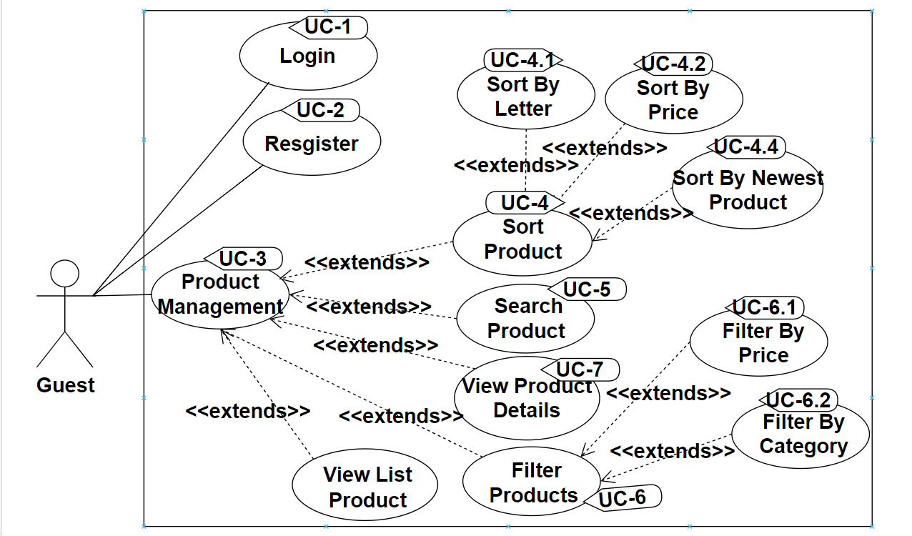

Figure 1.1 Use Case Guest

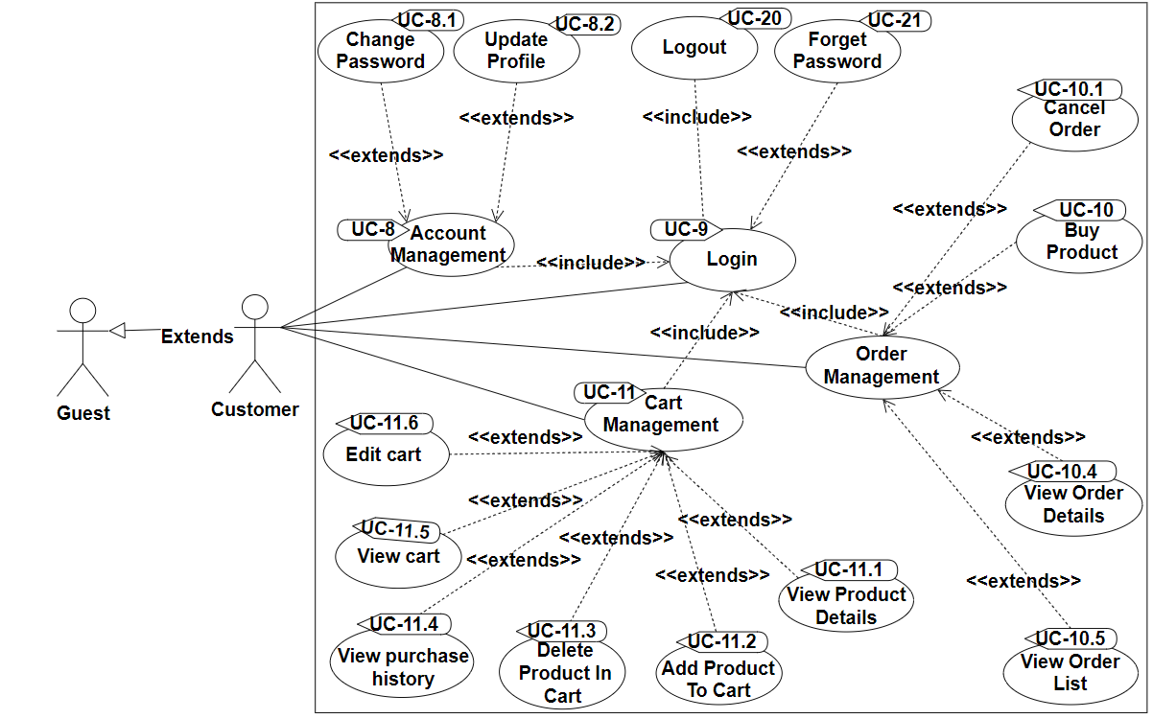

Figure 1.2 Use Case Customer

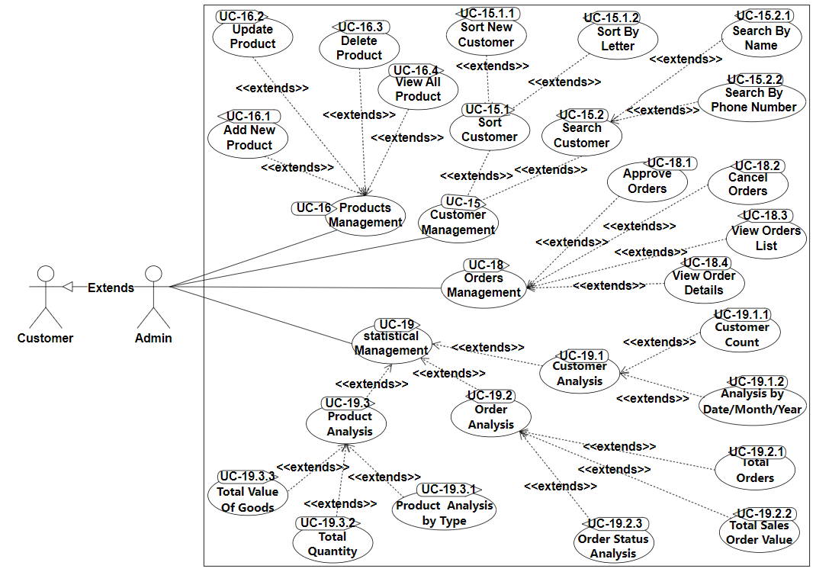

Figure 1.3 Use Case Admin

### b. Descriptions

|  |  |  |  |
| --- | --- | --- | --- |
| **ID** | **Feature** | **Use Case** | **Use Case Description** |
| 01 | Login | Login | Allow users to log in to their accounts. |
| 02 | Register Account | Register Account | Provide a process for users to create a new account within the system. |
| 03 | Sort Product | Sort Product By Price | Allows users to sort products based on product price |
| 04 | Sort Product | Sort Product By New Product | Allows users to sort through the site's newest products |
| 05 | Search Product | Search Product By Name | Allows users to search for products based on name. |
| 06 | Filter products | Filter products by price | Filter products according to suggested prices |
| 07 | Filter products | Filter by brand | Filter products by recommended brands |
| 08 | Account Management | Change Password | Provide functionality for users to change their account passwords. |
| 09 | Account Management | Update Profile | Allows users to update personal information |
| 10 | Login | Forget Password | Assist users in recovering or resetting their forgotten passwords. |
| 11 | Login | Logout | Provide an option for users to log out of their accounts. |
| 12 | Order Management | Cancel Order | Provide users with the ability to cancel an order before it is processed or delivered. |
| 13 | Order Management | Buy Product | Allow customers to add products to their cart and complete the order process. |
| 14 | Order Management | View Order Detail | Allows customers to view details about orders and products ordered |
| 15 | Order Management | View Order List | Allows customers to view all orders placed |
| 16 | Cart Management | Edit Cart | Allows customers to edit products in the shopping cart |
| 17 | Cart Management | View Cart | Allows customers to view all products in the shopping cart |
| 18 | Cart Management | View Purchase History | Allows customers to review ordered products |
| 19 | Cart Management | Delete Product | Allows customers to remove products from the cart |
| 20 | Cart Management | Add Product | Allow customers to add products to their cart |
| 21 | Product Management | Update Product | Provide administrators with the ability to update details of existing products in the system. |
| 22 | Product Management | Delete Product | Allow administrators to delete products that are no longer part of the inventory. |
| 23 | Product Management | View Product Details | Allows admin to view all products detail in the system |
| 24 | Product Management | View All Product | Allows admin to view all products in the system |
| 25 | Product Management | Add New Product | Allow administrators to input and add new products, including details such as name, description, and price,size… |
| 26 | Customer Management | Sort Customer By Letter | Allow administrators to sort customer information based on specified criteria. |
| 27 | Customer Management | Sort New Customers | Admin arranges newest customers |
| 28 | Customer Management | Search Customer By Name | Allow administrators to search for specific customer information based on defined criteria. |
| 29 | Customer Management | Search Customer By Number Phone | Admin searches for customers by phone number |
| 30 | Order Management | Order Confirmation | Confirm and acknowledge customer orders to ensure accuracy and transparency in the order processing system. |
| 31 | Order Management | View Order list for Confirmation | Admin to view the entire list of order statuses |
| 32 | Order Management | View Order List | Admin can view all orders that customers have placed |
| 33 | Order Management | View Order Details | Admin can view all order information that customers have placed such as product quantity, size |
| 34 | statistical Management | Statistics on sales | Allows admin to view all sales statistics |
| 35 | statistical Management | Statistics on total quantity of goods | Allows admin to view all goods quantity |
| 36 | statistical Management | Statistics on total value of goods | Allows admin to view the price of all goods |
| 37 | statistical Management | Total number of customers | Allows admin to view all customers registered in the system |
| 38 | statistical Management | Statistics on total orders | Allows admin to view all orders |
| 39 | statistical Management | Customer statistics by day/month/year | Allows admin to view customer statistics by day/month/year |
| 40 | statistical Management | Statistics on the total price of sold orders | Allows admin to view statistics on total orders sold in the system |
| 41 | statistical Management | Order status statistics(Waiting/Accept) | Allows admin to view statistics on orders that have been accepted or are in waiting position |

## 2. Overall Functionalities

### 2.1 Screens Flow

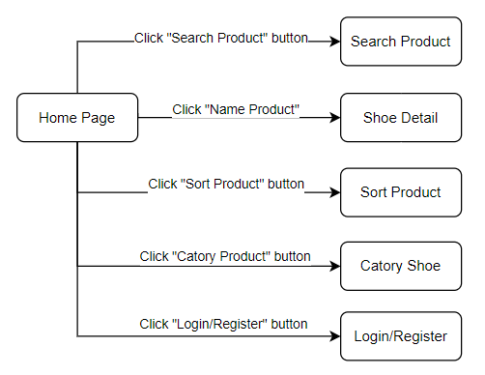

Figure 2.1 Screens Flow Guest

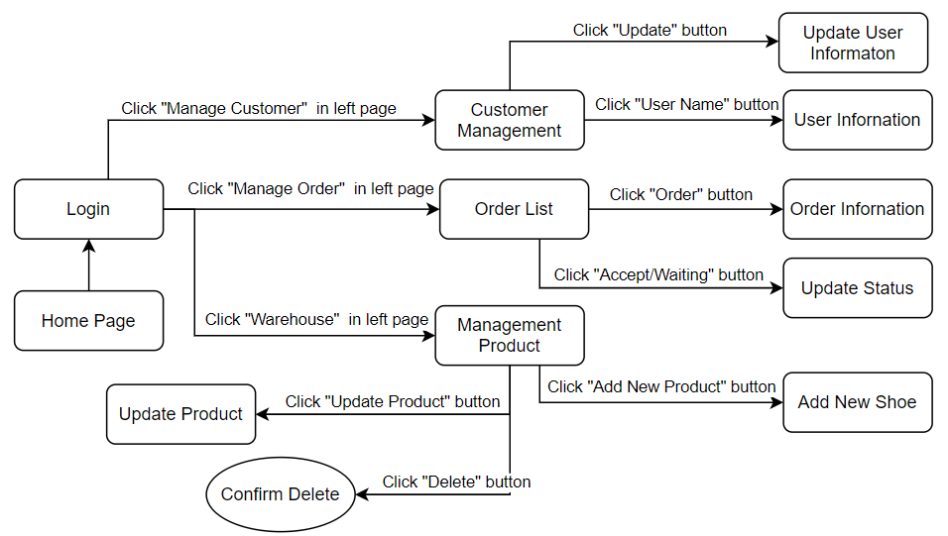

Figure 2.2 Screens Flow Admin

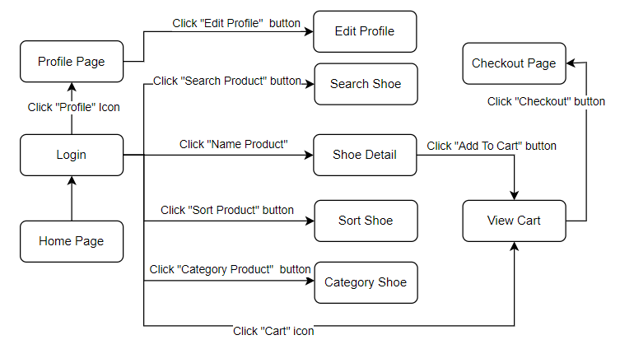

Figure 2.3 Screens Flow User

### 2.2 Screen Descriptions

|  |  |  |  |
| --- | --- | --- | --- |
| **#** | **Feature** | **Screen** | **Description** |
| 1 | Register Account | Register | + Allows users to create new accounts by entering information such as name, phone number, email, and password |
| 2 | Forgot password | Forgot Password | + Allows users to retrieve their password by entering their registered email and answering security questions |
| 3 | Login | User Page | + This is the page or interface for the end user (regular user). It provides features such as viewing account information, viewing products, adding products to cart, and making payments. |
| 4 | Login | Admin Page | + "ADMIN page" is the page or interface for the administrator or manager of a website or application. It typically provides tools and features to manage users, products, orders, reporting, and other aspects of the system. "ADMIN page" is also considered a screen because it allows the administrator to interact with the system in the form of a graphical interface. |
| 5 | View all products | Home Page | + Show the customer all off the products in the store group by categories |
| 6 | Search for products | Home Page | + Allow customer to search for product by entering the name of it in the searching bar |
| 7 | View cart | Cart Page | + Product list  + Number of products  + Total amount  + Delete product  + Link to product page  + Link to payment page  + Notifications and instructions |
| 8 | View order status | Status Page | + Show customers a list of orders they have made, group by the status of that order (sent or not yet) |
| 9 | View list of orders | Status Page | + Show list of orders and detailed information of the order |
| 10 | Put product into cart | Detail product | + Display product details and let customers add products to the cart by clicking "add to cart" |
| 11 | Put product into cart | Buy product | + Allows customers to put products directly into the shopping cart by clicking to buy |
| 12 | Product Management | Product Management Page | +Add New Shoe  + Shoe Information +Edit Shoe  +Delete Shoe |
| 13 | View information of Product | Product Management Page | +View information of name, quantity, date, etc. of products in the warehouse |
| 14 | Edit information of a warehouse | Product Management Page | + Show the Product Manager the information of the product and let him to update when there are changes |
| 15 | Add new product | Product Management Page | +Allow the Product Manager to add new product into the database |
| 16 | Account Management | User Account Page | + Edit Account Information + Delete Account |
| 17 | View all accounts | Admin Page | + Show all the user accounts of the web application, group by their roles |
| 18 | Update Status of Order | Admin Page | + Update status of order to (approved and not approved) |
| 19 | Management account information | Admin Page | + Update account information  + Delete account information |
|  |  |  |  |

### 2.3 Screen Authorization

|  |  |  |  |  |
| --- | --- | --- | --- | --- |
| **#** | **Screen** | **Admin** | **Customer** | **Guest** |
| 1 | Sort Product |  | **x** | **x** |
| 2 | Login | **x** | **x** |  |
| 3 | Register | **x** | **x** | **x** |
| 4 | Verify account | **x** | **x** |  |
| 5 | Admin page | **x** |  |  |
| 6 | Product management | **x** |  |  |
| 7 | Add new shoe | **x** |  |  |
| 8 | Confirm delete | **x** |  |  |
| 9 | Shoe information | **x** |  |  |
| 10 | Edit shoe | **x** |  |  |
| 11 | User list | **x** |  |  |
| 12 | Confirm delete | **x** |  |  |
| 13 | User information | **x** |  |  |
| 14 | Order list | **x** |  |  |
| 15 | Order information | **x** |  |  |
| 16 | User page |  | **x** |  |
| 17 | User profile |  | **x** |  |
| 18 | Order’s status |  | **x** |  |
| 19 | Shoe list |  | **x** |  |
| 20 | Shoe detail |  | **x** |  |
| 21 | View cart |  | **x** |  |
| 22 | Payment page |  | **x** |  |
| 23 | Search Product |  | **x** | **x** |

### 2.4 Non-UI Functions

|  |  |  |  |
| --- | --- | --- | --- |
| **#** | **Feature** | **System Function** | **Description** |
| 1 | Inventory management | Batch Job | Product inventory management function, updating the remaining quantity of the product and notifying if out of stock |
| 2 | Payment integration | Service | Use an external payment service to process payment transactions, including credit card checks, payment processing, and recording payment status on the system. |

## 3. System High Level Design

### 3.1 ERD

### 3.2 Database Design

#### a. Database

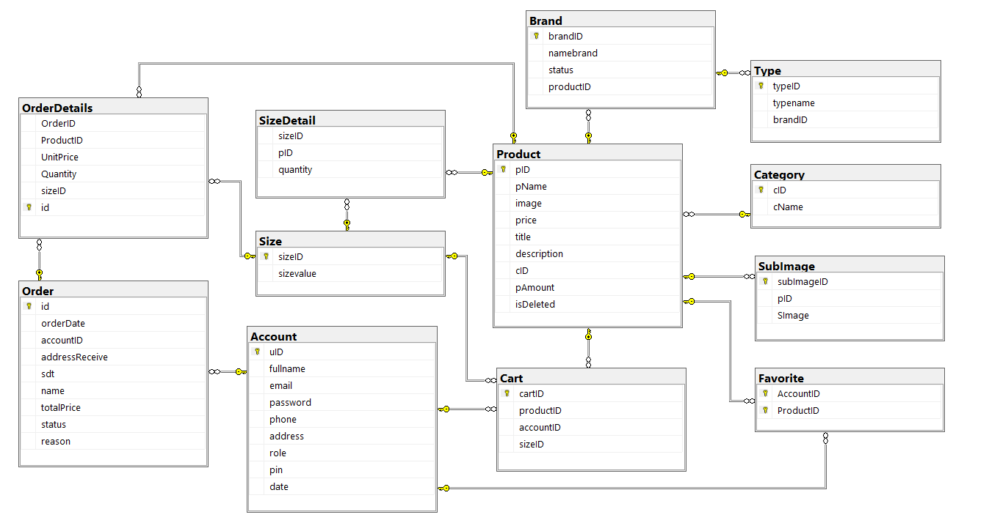

Figure 3.2 Database

#### b. Table Descriptions

|  |  |  |
| --- | --- | --- |
| **No** | **Table** | **Description** |
| 01 | brand | Description  Stores information about brands associated with products.  - Primary keys: brandID  - Foreign keys: productID (linked to the product table)  Columns:  - brandID (int): Primary key, unique identifier for each brand.  - productID (int): Foreign key, linking to the product table.  -name (nvarchar(255)): The name of the brand (up to 255 characters).  - status (int): Represents the status of the brand. |
| 02 | product | Description:  - Primary key: pID  - Foreign key: productID (linked to cart table)  Column:  - pID(int): Primary key, unique identifier for each product.  - pName(nvarchar(MAX)): Product name (MAX characters).  - title(nvarchar(MAX)): product title (max characters)  - description (text): Text description of the product.  - cID(int): Product description text.  - image(nvarchar(MAX)): URL or path to product image.  - price (decimal(10,2)): Price of the product.  -amount(int): Amount of products available. |
| 03 | account | Store information about customer accounts.  - Primary key: uID  - Foreign keys: accountID (linked to cart table)  Column:  - uID(int): Primary key, unique identifier for each customer account.  - fullname (nvarchar(255)): Customer name.  - email (nvarchar(255)): Customer's email address.  - password (nvarchar(255)): Password of the account.  - address(nvarchar(255)): address of the account.  - phone(int): phone number of the account.  - role (int): Represents the account's role (eg customer, administrator).  - pin(int): save pin code when creating account  - date(date): save the date the account was created |
| 04 | orderdetail | Store detailed product information in orders.  - Primary key: id  - Foreign key: ProductID (linked to product table), order_id  - Foreign key: SizeID (linked to Size table), SizeID  Column:  - orderID (int): Primary key, unique identifier for each order item.  - ProductID(int): Foreign key, link to product table.  - orderID(int): Foreign key, link to order table.  - quantity (int): Number of products in the order.  - sizeID(int): shoe size. |
| 05 | cart | Stores information about items in a customer's shopping cart.  - Primary key: cartID  - Foreign keys: ProductID (linked to product table), orderID,  - Foreign key: SizeID (linked to Size table), SizeID  - Foreign key: accountID (linked to Account table), accountID  Column:  - cartID(int): Primary key, unique identifier for each item in the cart.  - ProductID(int): Foreign key, link to product table.  - orderID(int): Foreign key, link to order table.  - accountID(int): Foreign key, associated with the customer account. |
| 06 | order | Store information about customer orders.  - Primary key: id  - Foreign key: AccountID (linked to account table)  Column:  - id(int): Primary key, unique identifier for each order.  - accountID(int): Foreign key, associated with the customer account.  - orderDate(datetime): Date and time of order.  - TotalPrice(decimal(10,2)): Total order value.  - status(int): Represents the status of the order.  - addressReceive(nvarchar(255)): Delivery address for the order.  - phone (int): Contact phone number for ordering.  -reason(nvarchar(MAX)): reason for canceling the order |
| 07 | size | Stores information about the product's size  - Primary key: sizeID  Column:  - sizeID(int): Primary key, identifier for size.  - sizeValue(int): stores the value of size. |
| 08 | Favorite | Stores favorite products  - Primary key: AccountID.  - foreign key: ProductID  Column:  - AccountID(int): Primary key, identification for the customer.  - Product(int): subkey identifying the favorite product. |
| 09 | subImage | Stores favorite products  - Primary key: subImageID  - foreign key: pID, associated with key pID of the Product table  Column:  - subImageID(int): Primary key, identifier for the image link.  - pID(int): subkey identifying the image of any product. |
| 10 | Category | Stores the product's category  - Primary key: cID  - foreign key: cName, linked to key pName of Product table  Column:  - cID(int): Primary key, identifier for the product type.  - cName(int): subkey identifies any name of that type. |
| 11 | Type | Stores type of product  - Primary key: typeID  -foreign key: bandID  Column:  -typeID (int): Primary key  -typeName(nvarchar(255)): name type of product  -bandID(int): Foreign key |

### 3.3 Code Packages

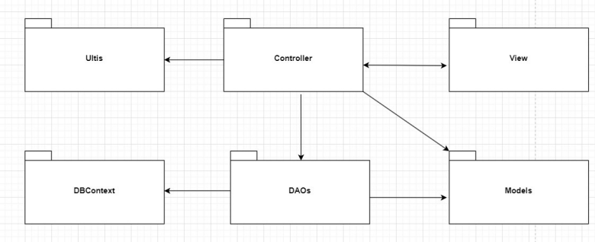

Figure 3.3 Code Packages

***Package descriptions***

|  |  |  |
| --- | --- | --- |
| No | Package | Description |
| 01 | View | This package includes a front-end source with jsp page, css, JavaScript,images,icon,font,bootstrap and jquery library. |
| 02 | Models | This package contains entities(classes) Product,Cart,Oder,User,Staff, etc that can be accessed and used by other classes DAO. |
| 03 | DAOs | Includes class ProductDAO, CartDAO, OderDAO, UserDAO, and etc with detailed functions that can interact directly with the database for data processing to which the Controller can load data for the user. |
| 04 | Controller | Includes Servlet with a responsibility to process, transfer the data collected by the user on web page(view) to DAO and Model in the database to JSP page. |
| 05 | DBContext | This package helps connect database |
| 06 | Ultis | This package contains a Helper class with functions for sending email,random new password, and interacting with users by email. |

# II. Requirement Specifications

## 1. Common Functions

### **1.2 UC-2_Register_Account**

#### **a. Functional Description**

|  |  |  |  |
| --- | --- | --- | --- |
| **UC ID and Name:** | UC-2_Register Account | | |
| **Created By:** | PhucPH | Date Created: | 13/January/2024 |
| **Primary Actor:** | Customer | Secondary Actors: | KiA Web Shop System |
| **Trigger:** | User clicks the Register button from the login page or the main page, or User accesses the Register feature | | |
| **Description:** | Users want the ability to register a new account on the system to access special features and track personal shopping history. | | |
| **Preconditions:** | User is not logged into the system | | |
| **Post-conditions:** | User successfully registers a new account.  The system creates and records the new account in the User Database. | | |
| **Normal Flow** | User clicks the Register button from the login page or the main page or accesses the Register feature.  User enters necessary information to create a new account (name, email, password, etc.).  User confirms the intention to register.  The system checks and verifies the information, ensuring no duplicates.  The system creates a new account and sends a registration confirmation to the user's email (if needed).  User logs into the system with the new account. | | |
| **Alternative Flows:** | 2.0.A1 Duplicate Username or Email:  The system detects a duplicate username or email.  The system prompts the user with an error message about the duplication.  The user is required to provide non-duplicate information.  Return to step 3 of the normal flow. | | |
| **Exceptions:** | 2.0.E1 Technical Failure:  The system encounters a technical issue during registration.  An error message is displayed, informing the user about the technical problem.  The user is advised to try again later.  If the issue persists, the user is urged to contact support. | | |
| **Priority:** | Must Have | | |
| **Frequency of Use:** |  | | |
| **Business Rules:** | BR1, BR2 | | |

#### **b. Business Rules**

|  |  |  |
| --- | --- | --- |
| **ID** | **Business Rule** | **Business Rule Description** |
| BR1 | Password Encoding | User’s password must be encoded with MD5 hashing |
| BR2 | Account creation failed | Users cannot create an account if they make the following errors  · email matches the registered email  . invalid phone number  . Password is not of sufficient length |

### **1.3 UC-3_ViewAllProduct**

#### **a. Functional Description**

|  |  |  |  |
| --- | --- | --- | --- |
| UC ID and Name: | **UC-3_ View All Product** | | |
| Created By: | NgaNT | Date Created: | 14/January/2024 |
| Primary Actor: | Customer | Secondary Actors: | KiA Web Shop System |
| Trigger: | The "View All Product" functionality is triggered when a customer logs into the system and specifically navigates to the "Products" or "Shop" section, indicating the intent to explore and view all available products within the system. | | |
| Description: | The "View All Product" use case allows customers to browse and view all available products in the system. | | |
| Preconditions: | The customer is logged into the system.  The product database contains items. | | |
| Postconditions: | The customer can see a comprehensive list of all products available in the system. | | |
| Normal Flow | customer navigates to the "View All Product" section.  System retrieves and displays a list of all products.  Customers can browse through the list, view product details, and make selections. | | |
| Alternative Flows: | If the product database is empty or does not contain any items, the system should handle this situation gracefully, perhaps by displaying a message indicating the unavailability of products. | | |
| Exceptions: | Empty Product Database:  If the product database is empty, a message is displayed indicating the unavailability of products.  Technical Issues:  In case of technical problems, an error message is presented, guiding the user to try again later. | | |
| Priority: | Medium | | |
| Frequency of Use: | High | | |
| Business Rules: | BR1, BR2, BR3 | | |
| Other Information: | Customers' Successful Login:  It is assumed that customers have successfully logged into the system before accessing the "View All Product" functionality. Proper authentication measures are in place to ensure the security of customer accounts.  Regular Database Updates:  The assumption is made that the product database is regularly updated with accurate information. This ensures that customers are presented with the most current and relevant product details. | | |
| Assumptions: | Customers have successfully logged into the system.  The product database is regularly updated with accurate information. | | |

#### **b. Business Rules**

|  |  |  |
| --- | --- | --- |
| **ID** | **Business Rule** | **Business Rule Description** |
| BR1 | Consistent Product Information Format: | All product information presented in the "View All Product" functionality must follow a consistent format. This includes details such as product name, description, price, and any other relevant information. Consistency ensures a cohesive and professional presentation of products to enhance the user experience. |
| BR2 | Accurate and Up-to-Date Product Data: | The product database must be regularly updated with accurate and current information. Any changes to product details, availability, or pricing should reflect immediately in the "View All Product" section. This rule ensures that customers are provided with reliable and relevant information when exploring the product catalog. |
| BR3 | Product Availability and Inventory Management: | The "View All Product" functionality should accurately reflect the availability of products based on the current inventory status. If a product is out of stock, it should be clearly indicated in the product listing. Additionally, the system should manage inventory levels to prevent overselling and ensure that customers are informed about product availability. |

### **1.5 UC-5_Search product**

#### **a. Functional Description**

|  |  |  |  |
| --- | --- | --- | --- |
| UC ID and Name: | **UC-5_ Search Product** | | |
| Created By: | NgaNT | Date Created: | 13/January/2024 |
| Primary Actor: | Customer | Secondary Actors: | KiA Web Shop System |
| Trigger: | Customer's initiation of a product search. | | |
| Description: | This use case outlines the functionality related to customers searching for products within the system. | | |
| Preconditions: | The customer must be logged into the system. | | |
| Postconditions: | Search results are displayed to the customer based on the entered criteria. | | |
| Normal Flow | The customer initiates a product search.  The system provides a user-friendly search interface to the customer.  The customer enters search criteria such as keywords, filters, or any relevant information.  The system processes the entered criteria and conducts a search within the product database.  The system presents the customer with a list of products that match the search criteria.  The customer can view detailed information about each product, including but not limited to product description, price, and availability. | | |
| Alternative Flows: | No Search Results  Description: If no products match the customer's search criteria, the system provides feedback indicating that no results were found.  Technical Issue During Search  Description: In case of technical issues or errors during the search process, the system provides an appropriate error message to the customer. | | |
| Exceptions: | If no products match the search criteria, the system should inform the customer appropriately.  In case of technical issues during the search process, the system should provide an error message and suggest the customer try again. | | |
| Priority: | Medium | | |
| Frequency of Use: | High | | |
| Business Rules: | BR-1, BR-2, BR-3, BR-4 | | |
| Other Information: | This functionality is crucial for enhancing the user experience, allowing customers to efficiently find and explore products within the system.  Search algorithms and criteria may be updated based on user feedback and system improvements. | | |
| Assumptions: | The assumption is that the product database is regularly updated and maintained for accurate search results.  Customers are assumed to have a basic understanding of how to use the search interface. | | |

#### **b. Business Rules**

|  |  |  |
| --- | --- | --- |
| **ID** | **Business Rule** | **Business Rule Description** |
| BR-1 | Search Criteria Validation | The system ensures that entered search criteria are valid and adhere to predefined guidelines. |
| BR-2 | Privacy and Security | Customer search queries and results are treated with strict privacy measures. No personally identifiable information is stored or shared. |
| BR-3 | Real-time Inventory Display | The system displays real-time product availability status based on the current inventory. Customers are provided accurate information on product availability. |
| BR-4 | Responsive Search Interface | The search interface is designed to be responsive and accessible across various devices and screen sizes, ensuring a consistent and user-friendly experience for all customers. |

### **1.5.1 UC-5.1_Search_By_Name**

#### **a. Functional Description**

|  |  |  |  |
| --- | --- | --- | --- |
| ID and Name: | **UC-5.1_Search By Name** | | |
| Created By: | Prithvi Raj | Date Created: | 14/January/2024 |
| Primary Actor: | Patron | Secondary Actors: | KiA Web Shop System |
| Description: | This use case describes the functionality of searching for items in the Cafeteria Inventory System by their name. | | |
| Trigger: | Patron's initiation of a search by name. | | |
| Preconditions: | The Patron is logged into the system. | | |
| Postconditions: | The system displays a list of items matching the search by name criteria. | | |
| Normal Flow: | 1. The Patron initiates a search by entering the name of the item in the search bar.  2. The system validates the input and processes the search by name request.  3. The Cafeteria Inventory System performs a search based on the entered name.  4. The system displays a list of items whose names match or partially match the entered criteria.  5. The Patron can view detailed information about each item, including its availability, price, and other relevant details. | | |
| Alternative Flows: | No Matching Items Found: If there are no items in the inventory that match the entered name criteria.  Technical Issue During Name Search: In case of technical issues or errors during the search by name process. | | |
| Exceptions: | 1. If there is a technical issue during the search process, the system displays an error message and prompts the Patron to try again.  2. If there are no items matching the search by name criteria, the system informs the Patron appropriately. | | |
| Priority: | Medium | | |
| Frequency of Use: | High (especially during busy hours in the cafeteria) | | |
| Business Rules: | BR-1, BR-2 | | |
| Other Information: | - The search by name functionality is critical for Patrons to quickly locate and access specific items in the cafeteria inventory.  - The system may provide auto-suggestions as the Patron types the item name for a more user-friendly experience. | | |
| Assumptions: | - The assumption is that the Cafeteria Inventory System is regularly updated to ensure accurate and real-time information for the search by name functionality.  - Patrons are assumed to have a basic understanding of how to use the search interface and enter item names. | | |

#### **b. Business Rules**

|  |  |  |
| --- | --- | --- |
| **ID** | **Business Rule** | **Business Rule Description** |
| BR-1 | Name Search Accuracy | The system must accurately match and display items whose names partially or fully match the entered search criteria. |
| BR-2 | Real-time Availability | The system must reflect real-time availability status based on the current inventory. |

### **1.9 UC-9_Login**

#### **a. Functional Description**

|  |  |  |  |
| --- | --- | --- | --- |
| **UC ID and Name:** | **UC-9_Login** | | |
| **Created By:** | PhucPH | Date Created: | 13/January/2024 |
| **Primary Actor:** | Customer | Secondary Actors: | KiA Web Shop System |
| **Trigger:** | User clicks Login button from the page header, or  User accesses an authenticated feature (from a link or type the page URL directly into the address bar) | | |
| **Description:** | As a user, I want to be able to log into the system so that I can use the system’s authenticated features and access my personalized account. | | |
| **Preconditions:** | User account has been created and authorized | | |
| **Post-conditions:** | User logs in the system successfully  The system tracked successful login into the Activity Log | | |
| **Normal Flow** | **9.0 Login System**  1. User accesses the User Login screen  2. User types in the login details or choo other login options (see 2.1 and 2.2)  3. User clicks the Login button  4. System validates the login details (see 2.0.E1)  5. System allows user to access  6. System tracks user’s success login to the Activity Log  7. System accesses the Home Page (or the previous calling page if any) | | |
| **Alternative Flows:** | **9.1 Google Login**  1. User chooses to login system using Google account  2. System redirects the user to the Google’s Login screen  3. User types in the Google account details and chooses to login  4. Google validates user’s login information successfully and redirect him/her back to the system  5. Return to step 5 of normal flow. | | |
| **Exceptions:** | **9.0.E1 System can’t authenticate the user**  1. The Error Message screen is shown to the user  2. User cancels the logging in => UC stops, change to UC-1_View Home Page  3. User clicks “Forgot Password?” link => change to UC-3_Reset Password  4. User clicks “Register” link => change to UC-4_Register User Account | | |
| **Priority:** | Must Have | | |
| **Frequency of Use:** |  | | |
| **Business Rules:** | BR-1, BR-2, BR-3 | | |

#### **b. Business Rules**

|  |  |  |
| --- | --- | --- |
| **ID** | **Business Rule** | **Business Rule Description** |
| BR1 | Password Encoding | User’s password must be encoded with MD5 hashing |
| BR2 | Invalid Logging In | User can’t be authenticated to login the system if below cases  · His/her logging-in details are incorrect  · His/her account has not been verified  · His/her account has been locked or blocked |
| BR3 | Account Locking | If user inputs wrong logging-in details 6 times continuously, his/her account would be locked in 30 minutes |

### **1.10 UC-10_Order**

#### **a. Functional Description**

|  |  |  |  |
| --- | --- | --- | --- |
| **UC ID and Name:** | **UC-10_Order** | | |
| **Created By:** | DuyNTQ | Date Created: | 14/January/2024 |
| **Primary Actor:** | Customer | Secondary Actors: | KiA Web Shop System |
| **Trigger:** | User clicks the Order button from the Cart. | | |
| **Description:** | This function allows users to create orders up to their hobbies. | | |
| **Preconditions:** | PRE-1: User is logged in. | | |
| **Post-conditions:** | POST-1: Order information is created and stored in the system.  POST-2: User receives confirmation of the orders. | | |
| **Normal Flow** | **10.0 Order**   1. User clicks the order button. 2. Users submit their information such as shipping address, phone number, name. 3. Users confirm their order request and continue shopping. | | |
| **Alternative Flows:** | Network connection gets trouble.   1. User information is cleared. 2. Return to step 1. | | |
| **Exceptions:** | **10.1.E1 System error**  If there is a system error, the system will display an error message and ask the user to try again later. | | |
| **Priority:** | Must Have | | |
| **Frequency of Use:** |  | | |
| **Business Rules:** | BR1, BR2, BR3 | | |

#### **b. Business Rules**

|  |  |  |
| --- | --- | --- |
| **ID** | **Business Rule** | **Business Rule Description** |
| BR1 | Order Confirmation | Staff must call the phone number user provided to confirm again. |
| BR2 | Shipping Hours | Order addresses that include the company, factory must be shipped at office hours. |
| BR3 | Information Encoding | User information must be encoded. |

### **1.11 UC-11_Cart Management**

#### **a. Functional Description**

|  |  |  |  |
| --- | --- | --- | --- |
| UC ID and Name: | **UC-11_Cart Management** | | |
| Created By: | NgaNT | Date Created: | 14/January/2024 |
| Primary Actor: | Customer | Secondary Actors: | KiA Web Shop System |
| Trigger: | Customer adds/removes items to/from the shopping cart | | |
| Description: | This use case describes the functionality related to managing the shopping cart for customers. | | |
| Preconditions: | - The customer is logged in.  - The customer has items in their shopping cart. | | |
| Postconditions: | The shopping cart is updated with the changes made by the customer. | | |
| Normal Flow | 1. Customer selects items to add to the shopping cart.  2. System adds the selected items to the shopping cart.  3. Customer reviews the items in the shopping cart.  4. Customer adjusts quantities or removes items from the shopping cart.  5. System updates the shopping cart based on customer modifications. | | |
| Alternative Flows: | Customer Adds Out-of-Stock Item to Cart  Customer attempts to add an item to the cart.  System detects that the selected item is currently out of stock.  System notifies the customer about the unavailability of the item.  Customers can choose to remove the out-of-stock item or continue shopping with available items. | | |
| Exceptions: | - If the customer is not logged in, the system prompts the customer to log in before allowing cart management.  - If an item is out of stock or unavailable, the system notifies the customer.  - If there is an issue updating the shopping cart, an error message is displayed. | | |
| Priority: | Medium | | |
| Frequency of Use: | High | | |
| Business Rules: | BR-1, BR-2, BR-3, BR-4 | | |
| Other Information: | - The shopping cart interface should be user-friendly and intuitive.  - The system should support multiple payment options when checking out from the shopping cart. | | |
| Assumptions: | - The system has accurate and up-to-date information on product availability and pricing.  - The customer has a stable internet connection for real-time updates. | | |

#### **b. Business Rules**

|  |  |  |
| --- | --- | --- |
| **ID** | **Business Rule** | **Business Rule Description** |
| BR-1 | The customer must be logged in to manage the shopping cart. | To access and manage the shopping cart, the customer needs to be authenticated by logging into their account. This ensures a personalized and secure shopping experience. |
| BR-2 | Items in the shopping cart should reflect the actual stock availability. | The system should continuously monitor and update the availability of items in the shopping cart based on the current stock levels. If an item becomes out of stock, the customer should be notified, preventing potential issues with order fulfillment. |
| BR-3 | The system should provide real-time updates on the total price in the shopping cart. | As the customer adds or removes items from the shopping cart, the system should dynamically calculate and display the total price. This ensures transparency and accuracy in the pricing information throughout the customer's shopping session. |
| BR-4 | Changes made by the customer to the shopping cart should be immediately reflected. | Any modifications made by the customer, such as adjusting quantities or removing items from the cart, should be instantly updated in the system. This real-time reflection ensures that the customer sees the most current information and helps prevent errors or discrepancies during the checkout process. |

### **1.11.1 UC-11.1_View Product Details**

#### **a. Functional Description**

|  |  |  |  |
| --- | --- | --- | --- |
| ID and Name: | **UC-11.1_View Product Details** | | |
| Created By: | NgaNT | Date Created: | 14/January/2024 |
| Primary Actor: | Patron | Secondary Actors: | KiA Web Shop System |
| Description: | This use case involves the functionality of viewing detailed information about a specific product within the cafeteria's inventory. Patrons can access this feature to get more information about a product before deciding to add it to their cart or make a purchase. | | |
| Trigger: | The patron selects a specific product to view details. | | |
| Preconditions: | - The patron is logged into the system.  - The cafeteria inventory system is operational. | | |
| Postconditions: | The patron has viewed the detailed information about the selected product. | | |
| Normal Flow: | 1. Patron navigates to the product catalog or selects a specific product.  2. System retrieves and displays detailed product information, including name, description, price, and nutritional details.  3. Patron reviews the information.  4. Patrons may choose to go back to the product catalog or proceed with adding the product to the cart. | | |
| Alternative Flows: | Patron Adds Product Directly to Cart from Details Page  Patron views the detailed information of a product.  Instead of going back to the catalog, the patron decides to add the product directly to the cart from the details page.  System adds the selected product to the patron's shopping cart. | | |
| Exceptions: | - If the selected product information cannot be retrieved, the system displays an error message.  - If there are technical issues during the process, the system may provide a message asking the patron to try again. | | |
| Priority: | Medium | | |
| Frequency of Use: | High | | |
| Business Rules: | BR-1, BR-2, BR-3 | | |
| Other Information: | - The system should support images or multimedia content to enhance the product details presentation.  - The product details page should have an option for patrons to add the item to their cart directly. | | |
| Assumptions: | - The cafeteria inventory system is regularly updated with accurate product information.  - Patrons have a stable internet connection for seamless access to product details. | | |

#### **b. Business Rules**

|  |  |  |
| --- | --- | --- |
| **ID** | **Business Rule** | **Business Rule Description** |
| BR-1 | Patrons must be logged in to view product details. | Access to detailed product information is restricted to authenticated patrons to ensure a personalized experience and track user interactions. |
| BR-2 | The system should provide accurate and up-to-date product information. | Product details should reflect the current state of the inventory to avoid misleading patrons with outdated information. |
| BR-3 | The detailed product information should be presented in a user-friendly and easily understandable format. | The information displayed to patrons should be clear, concise, and presented in a format that is easy to comprehend, enhancing the overall user experience. |

### **1.11.2 UC-11.2_Add Product**

#### **a. Functional Description**

|  |  |  |  |
| --- | --- | --- | --- |
| ID and Name: | **UC-11.2_Add Product** | | |
| Created By: | NgaNT | Date Created: | 14/January/2024 |
| Primary Actor: | Patron | Secondary Actors: | KiA Web Shop System |
| Description: | This use case involves the functionality of adding a specific product to the patron's shopping cart. Patrons can utilize this feature to initiate the process of purchasing a selected item from the cafeteria's inventory. | | |
| Trigger: | The patron selects the option to add a product to their shopping cart. | | |
| Preconditions: | - The patron is logged into the system.  - The product details are visible to the patron. | | |
| Postconditions: | The selected product is added to the patron's shopping cart. | | |
| Normal Flow: | 1. Patron navigates to the product details page.  2. Patron reviews the details of the product.  3. Patron selects the option to add the product to the cart.  4. System adds the selected product to the patron's shopping cart.  5. Patrons may continue shopping or proceed to checkout. | | |
| Alternative Flows: | Patron Adds Multiple Quantities of the Same Product | | |
| Exceptions: | - If there are technical issues during the process, the system displays an error message and prompts the patron to try adding the product again.  - If the selected product is out of stock or unavailable, the system notifies the patron and prevents adding it to the cart. | | |
| Priority: | Medium | | |
| Frequency of Use: | High | | |
| Business Rules: | BR-1, BR-2 | | |
| Other Information: | - The system should provide visual confirmation to the patron when a product is successfully added to the cart.  - Patrons should be able to view and manage the contents of their shopping cart easily. | | |
| Assumptions: | - The cafeteria inventory system is regularly updated with accurate product availability information.  - Patrons have a stable internet connection for seamless interactions with the shopping cart features. | | |

#### **b. Business Rules**

|  |  |  |
| --- | --- | --- |
| **ID** | **Business Rule** | **Business Rule Description** |
| BR-1 | Patrons must be logged in to add a product to the cart. | To ensure a personalized shopping experience and to associate the product with the correct patron, adding products to the cart is restricted to authenticated users. |
| BR-2 | The system should validate product availability before adding it to the cart. | Before allowing a product to be added to the cart, the system must confirm that the selected product is currently available in the cafeteria's inventory. |

### **1.11.3 UC-11.3_Delete Product**

#### **a. Functional Description**

|  |  |  |  |
| --- | --- | --- | --- |
| ID and Name: | **UC-11.3_Delete Product** | | |
| Created By: | NgaNT | Date Created: | 14/January/2024 |
| Primary Actor: | Patron | Secondary Actors: | KiA Web Shop System |
| Description: | This use case involves the functionality of deleting a selected product from the patron's shopping cart. Patrons can use this feature to remove items they no longer wish to purchase. | | |
| Trigger: | The patron selects the option to delete a product from their shopping cart. | | |
| Preconditions: | - The patron is logged into the system.  - The patron has at least one item in their shopping cart. | | |
| Postconditions: | - The selected product is removed from the patron's shopping cart. | | |
| Normal Flow: | 1. Patron navigates to their shopping cart.  2. Patron reviews the items currently in the shopping cart.  3. Patron selects the option to delete a specific product.  4. System removes the selected product from the shopping cart.  5. Patrons may continue shopping or proceed to checkout. | | |
| Alternative Flows: | Patron Clears Entire Cart | | |
| Exceptions: | - If there are technical issues during the process, the system displays an error message and prompts the patron to try deleting the product again. | | |
| Priority: | Medium | | |
| Frequency of Use: | High | | |
| Business Rules: | BR-1, BR-2, BR-3 | | |
| Other Information: | - The system should provide visual confirmation to the patron when a product is successfully deleted from the cart.  - Patrons should be able to easily navigate back to the shopping cart after deleting a product. | | |
| Assumptions: | - The cafeteria inventory system is regularly updated with accurate product availability information.  - Patrons have a stable internet connection for seamless interactions with the shopping cart features. | | |

#### **b. Business Rules**

|  |  |  |
| --- | --- | --- |
| **ID** | **Business Rule** | **Business Rule Description** |
| BR-1 | Patrons must be logged in to delete a product from the cart. | To ensure security and a personalized experience, the ability to delete items from the cart is restricted to authenticated users. |
| BR-2 | Patrons can only delete products that are currently in their shopping cart. | The system should validate that the product selected for deletion is currently present in the patron's shopping cart. |
| BR-3 | The system should provide confirmation before permanently deleting a product from the cart. | To prevent accidental deletions, the system should confirm the patron's intention to delete a product from the shopping cart before executing the action. |

### **1.11.4 UC-11.4_View Purchase History**

#### **a. Functional Description**

|  |  |  |  |
| --- | --- | --- | --- |
| ID and Name: | **11.4_View Purchase History** | | |
| Created By: | NgaNT | Date Created: | 14/January/2024 |
| Primary Actor: | Patron | Secondary Actors: | KiA Web Shop System |
| Description: | This use case involves the functionality of allowing patrons to view their purchase history. Patrons can access this feature to review a record of their past cafeteria purchases, providing insights into their buying patterns and aiding in reordering favorite items. | | |
| Trigger: | The patron selects the option to view their purchase history. | | |
| Preconditions: | - The patron is logged into the system. | | |
| Postconditions: | The patron has viewed their purchase history. | | |
| Normal Flow: | 1. Patron navigates to the account settings or purchase history section.  2. Patron selects the option to view purchase history.  3. System retrieves and displays a list of past purchases made by the patron.  4. Patrons can review details such as date, items purchased, and total cost.  5. Patrons may choose to reorder items from the purchase history or navigate back to other sections. | | |
| Alternative Flows: | Patron Filters Purchase History by Category  Patron Searches for Specific Items in Purchase History | | |
| Exceptions: | If there are technical issues during the process, the system displays an error message and prompts the patron to try viewing the purchase history again. | | |
| Priority: | Medium | | |
| Frequency of Use: | Moderate | | |
| Business Rules: | BR-1, BR-2 | | |
| Other Information: | - The system should provide options for sorting or filtering purchase history based on date, items, or total cost.  - Patrons may have the option to add items from the purchase history directly to their cart. | | |
| Assumptions: | - The cafeteria inventory system is regularly updated with accurate purchase history information.  - Patrons have a stable internet connection for seamless interactions with their purchase history. | | |

#### **b. Business Rules**

|  |  |  |
| --- | --- | --- |
| **ID** | **Business Rule** | **Business Rule Description** |
| BR-1 | Patrons must be logged in to view their purchase history. | Access to purchase history is restricted to authenticated patrons to ensure privacy and personalized information access. |
| BR-2 | The system should display an accurate and up-to-date list of past purchases. | The purchase history presented to patrons should reflect the most recent and accurate information to provide reliable insights. |

### **1.11.5 UC-11.5_View Cart**

#### **a. Functional Description**

|  |  |  |  |
| --- | --- | --- | --- |
| ID and Name: | **UC-11.5_View Cart** | | |
| Created By: | NgaNT | Date Created: | 14/January/2024 |
| Primary Actor: | Patron | Secondary Actors: | KiA Web Shop System |
| Description: | This use case involves the functionality of allowing patrons to view the contents of their shopping cart. Patrons can use this feature to review the items they have added, check quantities, and proceed to the checkout process. | | |
| Trigger: | The patron selects the option to view their shopping cart. | | |
| Preconditions: | - The patron is logged into the system.  - The patron has added at least one item to the shopping cart. | | |
| Postconditions: | - The patron has viewed the contents of their shopping cart. | | |
| Normal Flow: | 1. Patron navigates to the shopping cart section.  2. System retrieves and displays the current contents of the patron's shopping cart, including items, quantities, and total cost.  3. Patron reviews the items in the cart.  4. Patron may adjust quantities, remove items, or proceed to checkout | | |
| Alternative Flows: | none | | |
| Exceptions: | - If there are technical issues during the process, the system displays an error message and prompts the patron to try viewing the cart again. | | |
| Priority: | Medium | | |
| Frequency of Use: | High | | |
| Business Rules: | BR-1, BR-2,BR-3 | | |
| Other Information: | - The system should provide visual confirmation to the patron when the shopping cart is successfully loaded.  - Patrons should be able to easily navigate back to the shopping cart from other sections. | | |
| Assumptions: | - The cafeteria inventory system is regularly updated with accurate information on items in the shopping cart.  - Patrons have a stable internet connection for seamless interactions with their shopping cart. | | |

#### **b. Business Rules**

|  |  |  |
| --- | --- | --- |
| **ID** | **Business Rule** | **Business Rule Description** |
| BR-1 | Patrons must be logged in to view their shopping cart. | Access to the shopping cart is restricted to authenticated patrons to ensure privacy and personalized information access. |
| BR-2 | The system should display an accurate and up-to-date list of items in the shopping cart. | The shopping cart presented to patrons should reflect the most recent and accurate information to provide reliable insights. |
| BR-3 | Patrons can only view their own shopping cart. | The system should enforce security measures to prevent patrons from viewing shopping carts other than their own, ensuring privacy and data integrity. |

### **1.13 UC-13_RateProduct**

#### **a. Functional Description**

|  |  |  |  |
| --- | --- | --- | --- |
| **UC ID and Name:** | **UC-13_RateProduct** | | |
| **Created By:** | DuyNTQ | Date Created: | 14/January/2024 |
| **Primary Actor:** | Customer | Secondary Actors: | KiA Web Shop System |
| **Trigger:** | User clicks the Rate button from the Product. | | |
| **Description:** | This function allows users to rate on products after purchasing. | | |
| **Preconditions:** | PRE-1: User is logged in.  PRE-2: User bought at least 1 product | | |
| **Post-conditions:** | POST-1: Rate is created and shown on the website. | | |
| **Normal Flow** | User clicks the rate button.  Users submit their rating about the product.  Users confirm their rating and continue shopping. | | |
| **Alternative Flows:** | Network connection gets trouble.  Rating process is cleared.  Return to step 1. | | |
| **Exceptions:** | **13.0.E1 System error**  If there is a system error, the system will display an error message and ask the user to try again later. | | |
| **Priority:** | Must Have | | |
| **Frequency of Use:** | Medium | | |
| **Business Rules:** | BR1 | | |

#### **b. Business Rules**

|  |  |  |
| --- | --- | --- |
| **ID** | **Business Rule** | **Business Rule Description** |
| BR1 | Rating Policy | Rating must range from 1 stars to 5 stars. |

### **1.15.UC-15_Customer Management**

#### **a. Functional Description**

|  |  |  |  |
| --- | --- | --- | --- |
| **UC ID and Name:** | **UC-15_Customer Management** | | |
| **Created By:** | NgaNT | Date Created: | 14/January/2023 |
| **Primary Actor:** | Customer | Secondary Actors: | KiA Web Shop System |
| **Trigger:** | Various triggers such as account creation, login, profile update, or order placement can initiate customer management actions. | | |
| **Description:** | The Customer Management use case involves functionalities related to managing customer accounts and information within the system. This includes actions such as creating new accounts, updating profile information, managing preferences, and reviewing past orders. | | |
| **Preconditions:** | The system must be operational.  Customers must have valid accounts in the system to perform management actions. | | |
| **Postconditions:** | Customer information and preferences are updated accordingly within the system. | | |
| **Normal Flow** | Create Account:  Customer fills out the registration form with required information (e.g., name, email, password).  System validates the information and creates a new customer account.  Customer receives a confirmation email with account details.  Login:  Customer enters login credentials (email/username and password).  System verifies the credentials and grants access to the customer account.  View Profile:  Customer navigates to the profile section of their account.  System displays the customer's profile information, including name, contact details, and preferences.  Update Profile:  Customers edit their profile information as needed (e.g., changing address, updating email).  System validates the changes and updates the customer's profile.  View Order History:  Customers access the order history section of their account.  System displays a list of past orders, including details such as order date, items purchased, and order status. | | |
| **Alternative Flows:** | Social Media Account Authentication  Customers choose to sign up or log in using their social media account credentials (e.g., Facebook, Google).  System redirects the customer to the respective social media platform for authentication.  Upon successful authentication, the system creates a new account or logs in the customer using the social media account details.  Customers may be prompted to fill in additional profile information if necessary. | | |
| **Exceptions:** | If there are technical issues during any of the actions (e.g., account creation, profile update), the system displays an error message and prompts the customer to try again. | | |
| **Priority:** | Medium to High | | |
| **Frequency of Use:** | High | | |
| **Business Rules:** | BR-1, BR-2, BR-3, BR-4 | | |
| **Other Information:** | The system may offer additional features such as password reset, subscription management, and communication preferences.  Customer management functionalities contribute to a personalized and streamlined experience for users within the system. | | |
| **Assumptions:** | Customers have stable internet connectivity to access and manage their accounts.  The system is designed to handle concurrent customer management actions securely and efficiently. | | |

#### **b. Business Rules**

|  |  |  |
| --- | --- | --- |
| **ID** | **Business Rule** | **Business Rule Description** |
| BR-1 | Customers must provide valid and accurate information during account creation and profile updates. | To ensure data integrity and accuracy, customers are required to provide valid and up-to-date information when creating accounts or updating their profiles. |
| BR-2 | Customer passwords should be securely stored and encrypted within the system. | To protect customer data and privacy, passwords should be securely stored using encryption techniques to prevent unauthorized access. |
| BR-3 | Customers can only access and manage their own accounts and information. | The system should enforce security measures to prevent unauthorized access to customer accounts and ensure that customers can only view and manage their own information. |
| BR-4 | The system should provide appropriate validation and error handling to ensure smooth customer management processes. | The system should implement validation checks and error handling mechanisms to guide customers through the account management processes and prevent data entry errors or system failures. |

### **1.15.1 UC-15.1_ Sort Customer**

#### **a. Functional Description**

|  |  |  |  |
| --- | --- | --- | --- |
| **ID and Name:** | **UC-15.1_Sort Customer** | | |
| **Created By:** | NgaNT | Date Created: | 14/January/2024 |
| **Primary Actor:** | Patron | Secondary Actors: | KiA Web Shop System |
| **Description:** | The Sort Customer feature allows patrons to organize or arrange customer records based on specific criteria or attributes. This feature provides flexibility in managing and accessing customer information within the system | | |
| **Trigger:** | The trigger for utilizing the Sort Customer feature may include accessing the customer management section or initiating a search for specific customers. | | |
| **Preconditions:** | The system must be operational.  The patron must have appropriate access permissions to perform sorting actions on customer records. | | |
| **Postconditions:** | Customer records are sorted or organized according to the specified criteria. | | |
| **Normal Flow:** | Patron navigates to the customer management section or initiates a search for customers.  Patron selects the option to sort customer records.  Patron specifies the criteria for sorting (e.g., alphabetical order, registration date, total purchase amount).  System sorts the customer records based on the specified criteria and displays the sorted list to the patron. | | |
| **Alternative Flows:** | Reverse Sorting Order:  Patron selects the option to sort customer records.  Instead of the default ascending order, the patron chooses to sort the records in descending order.  System sorts the customer records accordingly, displaying them in reverse alphabetical, chronological, or numerical order.  Custom Sorting Criteria:  Patron selects the option to sort customer records.  Instead of predefined criteria, patrons opt for custom sorting criteria (e.g., sorting by last purchase date, number of orders placed).  Patron specifies the custom criteria for sorting.  System sorts the customer records based on the custom criteria provided by the patron. | | |
| **Exceptions:** | If there are technical issues during the sorting process, the system displays an error message and prompts the patron to try again. | | |
| **Priority:** | Medium | | |
| **Frequency of Use:** | Moderate | | |
| **Business Rules:** | BR-1, BR-2, BR-3 | | |
| **Other Information:** | The Sort Customer feature contributes to improved data management and facilitates customer analysis and segmentation.  Patrons may utilize sorting functionalities to identify valuable customers, analyze purchasing patterns, or generate targeted marketing campaigns. | | |
| **Assumptions:** | The system is capable of handling large volumes of customer records efficiently.  Patrons have a clear understanding of the available sorting options and how to utilize them effectively. | | |

#### **b. Business Rules**

|  |  |  |
| --- | --- | --- |
| **ID** | **Business Rule** | **Business Rule Description** |
| BR-1 | Patrons must have appropriate access permissions to use the Sort Customer feature. | Access to the Sort Customer feature should be restricted to authorized patrons to ensure data security and integrity. |
| BR-2 | The system should provide multiple sorting options to patrons, allowing them to sort customer records based on various criteria. | To cater to different use cases and preferences, the system should offer a range of sorting options (e.g., alphabetical, chronological, numerical) for organizing customer records. |
| BR-3 | Sorting should be performed efficiently, ensuring that customer records are accurately organized within a reasonable time frame. | The system should be optimized to handle sorting operations efficiently, especially when dealing with a large number of customer records, to provide a seamless user experience. |

### **1.15.1.1 UC-15.1.1_ Sort New Customer**

#### **a. Functional Description**

|  |  |  |  |
| --- | --- | --- | --- |
| **ID and Name:** | **UC-15.1.1_ Sort New Customer** | | |
| **Created By:** | NgaNT | Date Created: | 14/January/2024 |
| **Primary Actor:** | Patron | Secondary Actors: | KiA Web Shop System |
| **Description:** | The Sort New Customer feature allows patrons to organize or arrange newly registered customer records based on specific criteria or attributes. This feature provides patrons with the ability to efficiently manage and analyze newly acquired customer data within the system. | | |
| **Trigger:** | The trigger for utilizing the Sort New Customer feature may include accessing the customer management section or initiating a search for newly registered customers. | | |
| **Preconditions:** | The system must be operational.  There must be newly registered customers in the system to perform sorting actions. | | |
| **Postconditions:** | Newly registered customer records are sorted or organized according to the specified criteria. | | |
| **Normal Flow:** | Patron navigates to the customer management section or initiates a search for newly registered customers.  Patron selects the option to sort new customer records.  Patron specifies the criteria for sorting (e.g., registration date, source of registration).  System sorts the newly registered customer records based on the specified criteria and displays the sorted list to the patron. | | |
| **Alternative Flows:** | Automated Sorting Based on Registration Source:  Patron selects the option to sort new customer records.  Instead of manually specifying sorting criteria, patrons choose an automated sorting option based on the source of registration (e.g., website registration, mobile app registration).  System automatically sorts the new customer records based on the registration source and displays the sorted list to the patron. | | |
| **Exceptions:** | If there are technical issues during the sorting process, the system displays an error message and prompts the patron to try again. | | |
| **Priority:** | Medium | | |
| **Frequency of Use:** | Moderate | | |
| **Business Rules:** | BR-1, BR-2 | | |
| **Other Information:** | The Sort New Customer feature contributes to efficient customer acquisition and onboarding processes.  Patrons may utilize sorting functionalities to analyze the effectiveness of marketing campaigns, track customer acquisition trends, or identify potential leads among newly registered customers. | | |
| **Assumptions:** | The system is capable of handling large volumes of newly registered customer records efficiently.  Patrons have a clear understanding of the available sorting options and how to utilize them effectively. | | |

#### **b. Business Rules**

|  |  |  |
| --- | --- | --- |
| **ID** | **Business Rule** | **Business Rule Description** |
| BR-1 | Patrons must have appropriate access permissions to use the Sort New Customer feature. | Access to the Sort New Customer feature should be restricted to authorized patrons to ensure data security and integrity. |
| BR-2 | The system should provide multiple sorting options to patrons, allowing them to sort new customer records based on various criteria. | To cater to different use cases and preferences, the system should offer a range of sorting options (e.g., by registration date, source of registration) for organizing newly registered customer records. |

### **1.15.1.2 UC-15.1.2_ Sort Customer By Name(A-Z)**

#### **a. Functional Description**

|  |  |  |  |
| --- | --- | --- | --- |
| **ID and Name:** | **UC-15.1.2_ Sort Customer By Name(A-Z)** | | |
| **Created By:** | NgaNT | Date Created: | 14/January/2024 |
| **Primary Actor:** | Patron | Secondary Actors: | KiA Web Shop System |
| **Description:** | The Sort Customer By Name(A-Z) feature allows patrons to organize or arrange customer records alphabetically by name, from A to Z. This functionality provides patrons with an easy way to locate specific customers and maintain an organized database within the system. | | |
| **Trigger:** | The trigger for utilizing the Sort Customer By Name(A-Z) feature may include accessing the customer management section or initiating a search for customers. | | |
| **Preconditions:** | The system must be operational.  There must be existing customer records in the system to perform sorting actions. | | |
| **Postconditions:** | Customer records are sorted alphabetically by name in ascending order (A to Z). | | |
| **Normal Flow:** | Patron navigates to the customer management section or initiates a search for customers.  Patron selects the option to sort customer records by name in ascending order (A to Z).  System sorts the customer records alphabetically by name and displays the sorted list to the patron. | | |
| **Alternative Flows:** | Sort Customer By Name(Z-A):    Patron selects the option to sort customer records by name.  Instead of the default ascending order (A to Z), the patron chooses to sort the records in descending order (Z to A).  System sorts the customer records alphabetically by name in descending order and displays the sorted list to the patron. | | |
| **Exceptions:** | If there are technical issues during the sorting process, the system displays an error message and prompts the patron to try again. | | |
| **Priority:** | Medium | | |
| **Frequency of Use:** | Moderate | | |
| **Business Rules:** | BR-1, BR-2, BR-3 | | |
| **Other Information:** | The Sort Customer By Name(A-Z) feature enhances user experience by providing a quick and intuitive way to locate specific customers.  Patrons may utilize this feature for various purposes such as sending personalized communications, managing customer relationships, or analyzing customer demographics. | | |
| **Assumptions:** | The system is capable of handling large volumes of customer records efficiently.  Patrons have a clear understanding of the available sorting options and how to utilize them effectively. | | |

#### **b. Business Rules**

|  |  |  |
| --- | --- | --- |
| **ID** | **Business Rule** | **Business Rule Description** |
| BR-1 | Patrons must have appropriate access permissions to use the Sort Customer By Name(A-Z) feature. | Access to the Sort Customer By Name(A-Z) feature should be restricted to authorized patrons to ensure data security and integrity. |
| BR-2 | The system should perform case-insensitive sorting to ensure consistency and accuracy in alphabetical ordering. | The system should ignore case differences (e.g., uppercase vs. lowercase) when sorting customer names to prevent inconsistencies and ensure that all records are organized correctly. |
| BR-3 | Sorting should be performed efficiently, ensuring that customer records are accurately organized within a reasonable time frame. | The system should be optimized to handle sorting operations efficiently, especially when dealing with a large number of customer records, to provide a seamless user experience. |

### **1.15.1.3 UC-15.1.3_ Sort Customer By Name(Z-A)**

#### **a. Functional Description**

|  |  |  |  |
| --- | --- | --- | --- |
| **ID and Name:** | **UC-15.1.3_ Sort Customer By Name(Z-A)** | | |
| **Created By:** | NgaNT | Date Created: | 14/January/2024 |
| **Primary Actor:** | Patron | Secondary Actors: | KiA Web Shop System |
| **Description:** | The Sort Customer By Name(Z-A) feature allows patrons to organize or arrange customer records alphabetically by name, from Z to A. This functionality provides patrons with an alternative way to locate specific customers and maintain an organized database within the system. | | |
| **Trigger:** | The trigger for utilizing the Sort Customer By Name(Z-A) feature may include accessing the customer management section or initiating a search for customers. | | |
| **Preconditions:** | The system must be operational.  There must be existing customer records in the system to perform sorting actions. | | |
| **Postconditions:** | Customer records are sorted alphabetically by name in descending order (Z to A). | | |
| **Normal Flow:** | Patron navigates to the customer management section or initiates a search for customers.  Patron selects the option to sort customer records by name in descending order (Z to A).  System sorts the customer records alphabetically by name in descending order and displays the sorted list to the patron. | | |
| **Alternative Flows:** | Sort By Last Name Only:  Patron selects the option to sort customer records by last name in descending order.  Instead of sorting by full name, the patron chooses to sort only by last name.  System sorts the customer records alphabetically by last name in descending order and displays the sorted list to the patron. | | |
| **Exceptions:** | If there are technical issues during the sorting process, the system displays an error message and prompts the patron to try again. | | |
| **Priority:** | Medium | | |
| **Frequency of Use:** | High | | |
| **Business Rules:** | BR-1, BR-2 | | |
| **Other Information:** | The Sort Customer By Name(Z-A) feature provides patrons with additional flexibility in sorting customer records, catering to different user preferences.  Patrons may utilize this feature to analyze customer names in reverse alphabetical order, identify specific patterns, or prioritize follow-up actions. | | |
| **Assumptions:** | The system is capable of handling large volumes of customer records efficiently.  Patrons have a clear understanding of the available sorting options and how to utilize them effectively. | | |

#### **b. Business Rules**

|  |  |  |
| --- | --- | --- |
| **ID** | **Business Rule** | **Business Rule Description** |
| BR-1 | Patrons must have appropriate access permissions to use the Sort Customer By Name(Z-A) feature. | Access to the Sort Customer By Name(Z-A) feature should be restricted to authorized patrons to ensure data security and integrity. |
| BR-2 | Sorting should be performed efficiently, ensuring that customer records are accurately organized within a reasonable time frame. | The system should be optimized to handle sorting operations efficiently, especially when dealing with a large number of customer records, to provide a seamless user experience. |

### **1.15.2 UC-15.2_Search Customer**

#### **a. Functional Description**

|  |  |  |  |
| --- | --- | --- | --- |
| **ID and Name:** | **UC-15.2_Search Customer** | | |
| **Created By:** | NgaNT | Date Created: | 14/January/2024 |
| **Primary Actor:** | Patron | Secondary Actors: | KiA Web Shop System |
| **Description:** | The Search Customer feature allows patrons to search for specific customer records within the system based on various criteria. This functionality provides patrons with a convenient way to quickly locate and access relevant customer information. | | |
| **Trigger:** | The trigger for utilizing the Search Customer feature may include accessing the customer management section or initiating a search for customers. | | |
| **Preconditions:** | The system must be operational.  There must be existing customer records in the system to perform search actions. | | |
| **Postconditions:** | Patron successfully retrieves the desired customer information based on the search criteria. | | |
| **Normal Flow:** | Patron navigates to the customer management section or initiates a search for customers.  Patron enters the search criteria, which may include customer name, email address, phone number, or any other relevant information.  System performs a search based on the entered criteria and retrieves matching customer records.  System displays the search results to the patron, including relevant customer details such as name, contact information, and any other associated data. | | |
| **Alternative Flows:** | Advanced Search Options:  Patron selects the option for advanced search.  System presents additional search criteria such as purchase history, membership status, or location.  Patron enters specific values for the advanced search criteria.  System performs a refined search based on the advanced criteria and retrieves matching customer records.  System displays the search results, including relevant details based on the advanced search criteria. | | |
| **Exceptions:** | If no matching customer records are found based on the entered search criteria, the system displays a message indicating no results found.  If there are technical issues during the search process, the system displays an error message and prompts the patron to try again. | | |
| **Priority:** | Medium | | |
| **Frequency of Use:** | High | | |
| Business Rules: | BR-1, BR-2, BR-3 | | |
| **Other Information:** | The Search Customer feature streamlines the process of finding specific customer information, enhancing user productivity and satisfaction.  Patrons may utilize this feature for various purposes such as looking up customer contact details, reviewing purchase history, or updating customer profiles. | | |
| **Assumptions:** | The system is capable of handling search queries efficiently, even with large volumes of customer records.  Patrons have a clear understanding of the available search criteria and how to utilize them effectively. | | |

#### **b. Business Rules**

|  |  |  |
| --- | --- | --- |
| **ID** | **Business Rule** | **Business Rule Description** |
| BR-1 | Patrons must have appropriate access permissions to use the Search Customer feature. | Access to the Search Customer feature should be restricted to authorized patrons to ensure data security and integrity. |
| BR-2 | The system should support searching based on various customer attributes, including name, email, and phone number. | The search functionality should allow patrons to search for customers using different criteria to accommodate diverse search needs. |
| BR-3 | The search functionality should be optimized for efficiency, providing fast and accurate results to patrons. | The system should be optimized to perform search operations quickly and accurately, ensuring a seamless user experience for patrons conducting searches. |

### **1.15.2.1 UC-15.2.1_Search By Name**

#### **a. Functional Description**

|  |  |  |  |
| --- | --- | --- | --- |
| **ID and Name:** | **UC-15.2.1_Search By Name** | | |
| **Created By:** | NgaNT | Date Created: | 14/January/2024 |
| **Primary Actor:** | Patron | Secondary Actors: | KiA Web Shop System |
| **Description:** | The Search By Name feature allows patrons to search for specific customer records within the system based on the customer's name. This functionality provides patrons with a convenient way to quickly locate and access customer information by entering the name of the desired customer. | | |
| **Trigger:** | The trigger for utilizing the Search By Name feature may include accessing the customer management section or initiating a search for customers. | | |
| **Preconditions:** | The system must be operational.  There must be existing customer records in the system to perform search actions. | | |
| **Postconditions:** | Patron successfully retrieves the desired customer information based on the entered name. | | |
| **Normal Flow:** | Patron navigates to the customer management section or initiates a search for customers.  Patron selects the option to search by name.  Patron enters the name of the desired customer into the search bar.  System performs a search based on the entered name and retrieves matching customer records.  System displays the search results to the patron, including relevant customer details such as name, contact information, and any other associated data. | | |
| **Alternative Flows:** | Phonetic Name Search  Name Variants Search  Recent Searches History | | |
| **Exceptions:** | If no matching customer records are found based on the entered name, the system displays a message indicating no results found.  If there are technical issues during the search process, the system displays an error message and prompts the patron to try again. | | |
| **Priority:** | Medium | | |
| **Frequency of Use:** | High | | |
| **Business Rules:** | BR-1, BR-2 | | |
| **Other Information:** | The Search By Name feature provides patrons with a quick and efficient method to locate specific customer records by name.  Patrons may utilize this feature to search for customers they are familiar with or to verify customer details during interactions. | | |
| **Assumptions:** | The system is capable of handling search queries efficiently, even with large volumes of customer records.  Patrons have a clear understanding of how to enter the name of the desired customer effectively. | | |

#### **b. Business Rules**

|  |  |  |
| --- | --- | --- |
| **ID** | **Business Rule** | **Business Rule Description** |
| BR-1 | Patrons must have appropriate access permissions to use the Search By Name feature. | Access to the Search By Name feature should be restricted to authorized patrons to ensure data security and integrity. |
| BR-2 | The system should perform case-insensitive search to ensure consistency and accuracy in retrieving customer records by name. | The search functionality should ignore case differences (e.g., uppercase vs. lowercase) when searching for customer names to prevent inconsistencies and ensure that all matching records are retrieved accurately. |

### **1.15.2.2 UC-15.2.2_Search By Phone Number**

#### **a. Functional Description**

|  |  |  |  |
| --- | --- | --- | --- |
| **ID and Name:** | **UC-15.2.2_Search By Phone Number** | | |
| **Created By:** | NgaNT | Date Created: | 14/January/2024 |
| **Primary Actor:** | Patron | Secondary Actors: | KiA Web Shop System |
| **Description:** | The Search By Phone Number feature enables patrons to search for specific customer records within the system using the customer's phone number. This functionality provides patrons with a convenient way to quickly locate and access customer information by entering the phone number associated with the desired customer. | | |
| **Trigger:** | The trigger for utilizing the Search By Phone Number feature may include accessing the customer management section or initiating a search for customers. | | |
| **Preconditions:** | The system must be operational.  There must be existing customer records in the system to perform search actions. | | |
| **Postconditions:** | Patron successfully retrieves the desired customer information based on the entered phone number. | | |
| **Normal Flow:** | Patron navigates to the customer management section or initiates a search for customers.  Patron selects the option to search by phone number.  Patron enters the phone number of the desired customer into the search bar.  System performs a search based on the entered phone number and retrieves matching customer records.  System displays the search results to the patron, including relevant customer details such as name, contact information, and any other associated data. | | |
| **Alternative Flows:** | Partial Phone Number Search  International Phone Number Format | | |
| **Exceptions:** | If no matching customer records are found based on the entered phone number, the system displays a message indicating no results found.  If there are technical issues during the search process, the system displays an error message and prompts the patron to try again. | | |
| **Priority:** | Medium | | |
| **Frequency of Use:** | High | | |
| **Business Rules:** | BR-1, BR-2, BR-3 | | |
| **Other Information:** | The Search By Phone Number feature provides patrons with a quick and efficient method to locate specific customer records by phone number.  Patrons may utilize this feature to search for customers they have interacted with over the phone or to verify customer details during interactions. | | |
| **Assumptions:** | The system is capable of handling search queries efficiently, even with large volumes of customer records.  Patrons have a clear understanding of how to enter the phone number of the desired customer effectively. | | |

#### **b. Business Rules**

|  |  |  |
| --- | --- | --- |
| **ID** | **Business Rule** | **Business Rule Description** |
| BR-1 | Patrons must have appropriate access permissions to use the Search By Phone Number feature. | Access to the Search By Phone Number feature should be restricted to authorized patrons to ensure data security and integrity. |
| BR-2 | The system should support searching based on exact phone number matches to ensure accuracy in retrieving customer records. | The search functionality should only retrieve customer records that exactly match the entered phone number to prevent confusion or inaccuracies in the search results. |
| BR-3 | The search functionality should be optimized for efficiency, providing fast and accurate results to patrons. | The system should be optimized to perform search operations quickly and accurately, ensuring a seamless user experience for patrons conducting searches. |

### 

### **1.16 UC-16_Product Management**

#### **a. Functional Description**

|  |  |  |  |
| --- | --- | --- | --- |
| **UC ID and Name:** | **UC-16_Product Management** | | |
| **Created By:** | NgaNT | Date Created: | 14/January/2023 |
| **Primary Actor:** | Customer | Secondary Actors: | KiA Web Shop System |
| **Trigger:** | The trigger for utilizing the Product Management feature may include accessing the product management section, initiating product-related actions, or performing inventory management tasks. | | |
| **Description:** | The Product Management feature allows customers to manage various aspects of products within the system. This functionality provides customers with the ability to view, add, edit, and remove products from their inventory or shopping list. | | |
| **Preconditions:** | The system must be operational.  The customer must be authenticated and logged in to access the Product Management feature.  There must be existing product data in the system to perform product-related actions. | | |
| **Postconditions:** | Changes made to product data are successfully updated and reflected in the system. | | |
| **Normal Flow** | Customer navigates to the product management section or initiates a product-related action.  Customers view the list of available products or specific product details.  Customer performs actions such as adding a new product, editing existing product details, or removing a product.  System updates the product data based on the customer's actions and reflects the changes in the system. | | |
| **Alternative Flows:** | Quick Product Edit:  · Customer accesses the Product Management feature.  · Customer selects a product from the list and chooses the quick edit option.  · System presents a simplified form with fields for essential product details such as price or quantity.  · Customer makes the necessary changes directly in the form and submits the updates.  · System applies the changes to the selected product without navigating to a separate edit page.  Product Duplication:  · Customer accesses the Product Management feature.  · Customer selects a product from the list and opts to duplicate it.  · System creates a copy of the selected product, including all its details, except for the unique identifier.  · Customer makes any necessary modifications to the duplicated product, such as adjusting the name or price.  · System adds the duplicated product to the inventory, retaining the original product as well. | | |
| **Exceptions:** | If there are technical issues or errors during product management tasks, the system displays an error message and prompts the customer to try again.  If the customer attempts to perform unauthorized actions, such as editing products without proper permissions, the system denies the action and notifies the customer accordingly. | | |
| **Priority:** | Medium | | |
| **Frequency of Use:** | High | | |
| **Business Rules:** | BR-1, BR-2, BR-3, BR-4, BR-5 | | |
| **Other Information:** | The Product Management feature empowers customers to maintain and update their product inventory effectively, enhancing their overall experience with the system.  Customers may utilize this feature for various purposes, including adding new products, updating product details, and managing inventory levels. | | |
| **Assumptions:** | Customers have a clear understanding of the product management functionalities available to them within the system.  The system is capable of handling product management tasks efficiently, even with large volumes of product data. | | |

#### **b. Business Rules**

|  |  |  |
| --- | --- | --- |
| **ID** | **Business Rule** | **Business Rule Description** |
| BR-1 | Customers must be authenticated and logged in to access the Product Management feature. | Product management actions should be audited and logged for security and accountability purposes. |
| BR-2 | The system should enforce access control mechanisms to ensure that customers can only perform authorized product management actions. | Access control mechanisms should be in place to prevent unauthorized access or modification of product data by customers. |
| BR-3 | Product data should be validated to ensure accuracy and consistency when performing product-related actions. | The system should validate product data entered or modified by customers to prevent errors or inconsistencies in the product database. |
| BR-4 | The system should provide adequate feedback to customers regarding the outcome of product management actions, such as success or failure messages. | The system should communicate the results of product management actions clearly to customers to facilitate smooth interaction and decision-making. |
| BR-5 | Product management actions should be audited and logged for security and accountability purposes. | The system should maintain logs of product management actions performed by customers for auditing, tracking, and accountability purposes. |

### **1.16.1. UC-16.1_Add New Product**

#### **a. Functional Description**

|  |  |  |  |
| --- | --- | --- | --- |
| **ID and Name:** | **UC-16.1_Add New Product** | | |
| **Created By:** | NgaNT | Date Created: | 14/January/2024 |
| **Primary Actor:** | Patron | Secondary Actors: | KiA Web Shop System |
| **Description:** | The Add New Product feature allows patrons to add a new product to the cafeteria inventory system. This functionality provides patrons with the ability to expand the range of available products by entering details for the new product, such as name, description, price, and quantity. | | |
| **Trigger:** | The trigger for utilizing the Add New Product feature may include identifying the need for a new product in the cafeteria inventory system. | | |
| **Preconditions:** | The system must be operational.  The patron must be authenticated and logged in to access the Add New Product feature.  The patron should have appropriate permissions to add new products. | | |
| **Postconditions:** | The new product was successfully added to the cafeteria inventory system. | | |
| **Normal Flow:** | Patron navigates to the Add New Product section within the cafeteria inventory system.  Patron enters details for the new product, including name, description, price, and quantity.  Patron confirms the entered details and submits the new product for addition to the inventory.  System validates the entered information and adds the new product to the cafeteria inventory.  System displays a success message confirming the addition of the new product. | | |
| **Alternative Flows:** | Quick Add:  Patron accesses the Add New Product section within the cafeteria inventory system.  Instead of filling out individual fields, patrons select the quick add option.  Patron enters minimal information such as product name and price.  System automatically generates default values for other fields such as quantity and description.  Patron confirms the quick add and submits the new product.  System adds the new product to the cafeteria inventory with default values and displays a success message. | | |
| **Exceptions:** | If the entered product details are incomplete or invalid, the system prompts the patron to correct the errors before proceeding with the addition.  If there are technical issues during the addition process, such as database errors or connectivity issues, the system displays an error message and advises the patron to try again later. | | |
| **Priority:** | Medium | | |
| **Frequency of Use:** | Low to Medium | | |
| **Business Rules:** | BR-1, BR-2, BR-3 | | |
| **Other Information:** | The Add New Product feature empowers patrons to contribute to the expansion and diversification of the cafeteria inventory.  Patrons may utilize this feature to suggest new products based on their preferences or to fulfill specific demands within the cafeteria. | | |
| **Assumptions:** | Patrons have a clear understanding of the process for adding new products within the cafeteria inventory system.  The system is capable of handling new product additions efficiently, including data validation and database updates. | | |

#### **b. Business Rules**

|  |  |  |
| --- | --- | --- |
| **ID** | **Business Rule** | **Business Rule Description** |
| BR-1 | Patrons must be authenticated and logged in to access the Add New Product feature. | Access to the Add New Product feature should be restricted to authenticated patrons to ensure data security and integrity. |
| BR-2 | The system should enforce access control mechanisms to ensure that only authorized patrons can add new products. | Access control mechanisms should be in place to prevent unauthorized users from adding products to the cafeteria inventory. |
| BR-3 | Product details entered by patrons should be validated to ensure accuracy and consistency in the cafeteria inventory system. | The system should validate product details entered by patrons to prevent errors or inconsistencies in the cafeteria inventory database. |

### **1.16.2. UC-16.2_Update Product**

#### **a. Functional Description**

|  |  |  |  |
| --- | --- | --- | --- |
| **ID and Name:** | **UC-16.2_Update Product** | | |
| **Created By:** | NgaNT | Date Created: | 14/January/2024 |
| **Primary Actor:** | Patron | Secondary Actors: | KiA Web Shop System |
| **Description:** | The Update Product feature allows patrons to modify existing product details within the cafeteria inventory system. This functionality provides patrons with the ability to update product information such as name, description, price, and quantity to reflect changes in inventory or to correct any inaccuracies. | | |
| **Trigger:** | The trigger for utilizing the Update Product feature may include identifying the need to modify or correct existing product details within the cafeteria inventory system. | | |
| **Preconditions:** | The system must be operational.  The patron must be authenticated and logged in to access the Update Product feature.  The patron should have appropriate permissions to update product details. | | |
| **Postconditions:** | The updated product details are successfully saved and reflected in the cafeteria inventory system. | | |
| **Normal Flow:** | Patron navigates to the Update Product section within the cafeteria inventory system.  Patron selects the product they wish to update from the list of available products.  Patron modifies the desired product details such as name, description, price, or quantity.  Patron confirms the changes and submits the updated product details.  System validates the entered information and updates the product details in the cafeteria inventory system.  System displays a success message confirming the update of the product details. | | |
| **Alternative Flows:** | Batch Product Update:  Patron accesses the Update Product section within the cafeteria inventory system.  Instead of updating products one by one, patrons select the option for batch product update.  Patron uploads a CSV or Excel file containing updated details for multiple products, such as names, descriptions, prices, and quantities.  System processes the uploaded file and updates all the specified products in bulk.  System validates the updated data and displays any errors or inconsistencies for patron review.  Patron confirms the update, and the system applies the changes to the cafeteria inventory accordingly. | | |
| **Exceptions:** | If the entered product details are incomplete or invalid, the system prompts the patron to correct the errors before proceeding with the update.  If there are technical issues during the update process, such as database errors or connectivity issues, the system displays an error message and advises the patron to try again later. | | |
| **Priority:** | Medium | | |
| **Frequency of Use:** | Low to Medium | | |
| **Business Rules:** | BR-1, BR-2 | | |
| **Other Information:** | The Update Product feature empowers patrons to maintain accurate and up-to-date product information within the cafeteria inventory system.  Patrons may utilize this feature to correct any errors, update prices, or adjust quantities for existing products as needed. | | |
| **Assumptions:** | Patrons have a clear understanding of the process for updating product details within the cafeteria inventory system.  The system is capable of handling product updates efficiently, including data validation and database updates. | | |

#### **b. Business Rules**

|  |  |  |
| --- | --- | --- |
| **ID** | **Business Rule** | **Business Rule Description** |
| BR-1 | Patrons must be authenticated and logged in to access the Update Product feature. | Access to the Update Product feature should be restricted to authenticated patrons to ensure data security and integrity. |
| BR-2 | The system should enforce access control mechanisms to ensure that only authorized patrons can update product details. | Access control mechanisms should be in place to prevent unauthorized users from updating product details within the cafeteria inventory system. |

### **1.16.3. UC-16.3_Delete Product**

#### **a. Functional Description**

|  |  |  |  |
| --- | --- | --- | --- |
| **ID and Name:** | **UC-16.3_Delete Product** | | |
| **Created By:** | NgaNT | Date Created: | 14/January/2024 |
| **Primary Actor:** | Patron | Secondary Actors: | KiA Web Shop System |
| **Description:** | The Delete Product feature allows patrons to remove existing products from the cafeteria inventory system. This functionality provides patrons with the ability to manage the product inventory by removing products that are no longer available or needed. | | |
| **Trigger:** | The trigger for utilizing the Delete Product feature may include identifying products that need to be removed from the inventory due to various reasons such as discontinuation or unavailability. | | |
| **Preconditions:** | The system must be operational.  The patron must be authenticated and logged in to access the Delete Product feature.  The patron should have appropriate permissions to delete products. | | |
| **Postconditions:** | The selected product is successfully removed from the cafeteria inventory system. | | |
| **Normal Flow:** | Patron navigates to the Delete Product section within the cafeteria inventory system.  Patron selects the product they wish to delete from the list of available products.  Patron confirms the deletion of the selected product.  System prompts for confirmation to ensure the deletion is intentional.  Patron confirms the deletion, and the system removes the selected product from the cafeteria inventory.  System displays a success message confirming the deletion of the product. | | |
| **Alternative Flows:** | Soft Delete with Confirmation  Patron navigates to the Delete Product section within the cafeteria inventory system.  Patron selects the product they wish to delete from the list of available products.  Instead of immediately deleting the product, the system prompts for confirmation.  Patron confirms the deletion request.  System marks the selected product as "deleted" but retains it in the database.  Deleted products are hidden from regular product listings but remain accessible for administrators.  System displays a success message confirming the deletion request. | | |
| **Exceptions:** | If the selected product is associated with any active orders or transactions, the system may prevent its deletion and display a warning message to the patron.  If there are technical issues during the deletion process, such as database errors or connectivity issues, the system displays an error message and advises the patron to try again later. | | |
| **Priority:** | Medium | | |
| **Frequency of Use:** | High | | |
| **Business Rules:** | BR-1, BR-2, BR-3 | | |
| **Other Information:** | The Delete Product feature empowers patrons to maintain an accurate and up-to-date inventory by removing obsolete or unwanted products.  Patrons may utilize this feature to streamline the product selection and improve the efficiency of inventory management. | | |
| **Assumptions:** | Patrons have a clear understanding of the process for deleting products within the cafeteria inventory system.  The system is capable of handling product deletions efficiently, including data validation and database updates. | | |

#### **b. Business Rules**

|  |  |  |
| --- | --- | --- |
| **ID** | **Business Rule** | **Business Rule Description** |
| BR-1 | Patrons must be authenticated and logged in to access the Delete Product feature. | Access to the Delete Product feature should be restricted to authenticated patrons to ensure data security and integrity. |
| BR-2 | The system should enforce access control mechanisms to ensure that only authorized patrons can delete products. | Access control mechanisms should be in place to prevent unauthorized users from deleting products within the cafeteria inventory system. |
| BR-3 | Products cannot be deleted if they are associated with active orders or transactions to maintain data integrity. | The system should prevent the deletion of products that are currently associated with active orders or transactions to avoid data inconsistencies and ensure the accuracy of inventory records. |

### **1.16.4 UC-16.4_View Product Details**

#### **a. Functional Description**

|  |  |  |  |
| --- | --- | --- | --- |
| **ID and Name:** | **UC-16.4_View Product Details** | | |
| **Created By:** | NgaNT | Date Created: | 14/January/2024 |
| **Primary Actor:** | Patron | Secondary Actors: | KiA Web Shop System |
| **Description:** | The View Product Details feature allows patrons to access and review detailed information about products available in the cafeteria inventory system. This functionality provides patrons with essential details such as product name, description, price, and quantity, enabling informed decision-making while browsing the available products. | | |
| **Trigger:** | The trigger for utilizing the View Product Details feature may include patron's interest in exploring the attributes and specifications of a particular product within the cafeteria inventory system. | | |
| **Preconditions:** | The system must be operational.  The patron must be authenticated and logged in to access the View Product Details feature. | | |
| **Postconditions:** | The selected product details are successfully displayed to the patron. | | |
| **Normal Flow:** | Patron navigates to the View Product Details section within the cafeteria inventory system.  Patron selects the product they wish to view details for from the list of available products.  System retrieves and displays detailed information about the selected product, including its name, description, price, quantity, and any other relevant attributes.  Patron reviews the displayed product details.  Patrons may choose to navigate back to the product listing or perform other actions within the system. | | |
| **Alternative Flows:** | Unavailable Product Details:  If the selected product is temporarily unavailable or out of stock, the system may display a message indicating its unavailability instead of showing its details.  Limited Access:  In cases where certain patrons have restricted access to view specific product details (e.g., restricted products for underage patrons), the system may display only limited information or prompt the patron to seek assistance from an authorized personnel.  Product Not Found:  If the selected product is not found in the inventory system due to deletion or other reasons, the system may display an error message informing the patron that the requested product details are not available.  System Maintenance:  During scheduled system maintenance or updates, the system may temporarily disable the ability to view product details. In such cases, the system can display a maintenance message informing patrons about the temporary unavailability of the feature. | | |
| **Exceptions:** | If the selected product details cannot be retrieved from the system due to technical issues or database errors, the system displays an error message and advises the patron to try again later. | | |
| **Priority:** | Medium | | |
| **Frequency of Use:** | High | | |
| **Business Rules:** | BR-1, BR-2 | | |
| **Other Information:** | The View Product Details feature enhances the patron's shopping experience by providing comprehensive information about available products.  Patrons may utilize this feature to compare products, check availability, and make informed purchasing decisions. | | |
| **Assumptions:** | Patrons have a clear understanding of how to navigate and access product details within the cafeteria inventory system.  The system is capable of efficiently retrieving and displaying product details to patrons in real-time. | | |

#### **b. Business Rules**

|  |  |  |
| --- | --- | --- |
| **ID** | **Business Rule** | **Business Rule Description** |
| BR-1 | Patrons must be authenticated and logged in to access the View Product Details feature. | Access to view product details should be restricted to authenticated patrons to ensure data security and privacy. |
| BR-2 | Access to view product details may be restricted based on the patron's permissions and role within the system. | The system should enforce access control mechanisms to limit access to product details based on the patron's permissions and role within the organization. |

### **1.16.5 UC-16.5_View All Product**

#### **a. Functional Description**

|  |  |  |  |
| --- | --- | --- | --- |
| **ID and Name:** | **UC-16.5_View All Product** | | |
| **Created By:** | NgaNT | Date Created: | 14/January/2024 |
| **Primary Actor:** | Patron | Secondary Actors: | KiA Web Shop System |
| **Description:** | The View All Product feature allows patrons to browse and view a comprehensive list of all products available in the cafeteria inventory system. This functionality provides patrons with an overview of the entire product catalog, enabling them to explore available options and make informed purchasing decisions. | | |
| **Trigger:** | The trigger for utilizing the View All Product feature may include patron's interest in browsing the complete range of products offered by the cafeteria. | | |
| **Preconditions:** | The system must be operational.  The patron must be authenticated and logged in to access the View All Product feature. | | |
| **Postconditions:** | The complete list of products available in the cafeteria inventory is successfully displayed to the patron. | | |
| **Normal Flow:** | Patron navigates to the View All Product section within the cafeteria inventory system.  System retrieves and displays a comprehensive list of all products available in the cafeteria inventory.  Patron browses through the list of products, scrolling or navigating through multiple pages if necessary.  System displays essential details for each product, such as name, description, price, and quantity.  Patrons may choose to view additional details for specific products or proceed to make a selection. | | |
| **Alternative Flows:** | Pagination:  If the complete list of products is extensive, the system may implement pagination to break the list into manageable chunks. Patrons can navigate through different pages to view additional products.  Filtering and Sorting:  The system may offer filtering and sorting options to allow patrons to refine the displayed product list based on specific criteria such as category, price range, availability, etc. This provides patrons with more control over their browsing experience.  Search Functionality:  Patrons may have the option to search for specific products using keywords or filters. This allows patrons to quickly locate products of interest without having to browse through the entire list. | | |
| **Exceptions:** | If the complete list of products cannot be retrieved from the system due to technical issues or database errors, the system displays an error message and advises the patron to try again later. | | |
| **Priority:** | Medium | | |
| **Frequency of Use:** | High | | |
| **Business Rules:** | BR-1, BR-2, BR-3 | | |
| **Other Information:** | The View All Product feature provides patrons with a convenient way to explore the entire product catalog and discover available options.  Patrons may utilize this feature to compare products, check availability, and make informed purchasing decisions. | | |
| **Assumptions:** | Patrons have a clear understanding of how to navigate and access product listings within the cafeteria inventory system.  The system is capable of efficiently retrieving and displaying the complete product list to patrons in real-time. | | |

#### **b. Business Rules**

|  |  |  |
| --- | --- | --- |
| **ID** | **Business Rule** | **Business Rule Description** |
| BR-1 | Patrons must be authenticated and logged in to access the View All Product feature. | Access to view all product listings should be restricted to authenticated patrons to ensure data security and privacy. |
| BR-2 | Access to view all product listings may be restricted based on the patron's permissions and role within the system. | The system should enforce access control mechanisms to limit access to the complete product list based on the patron's permissions and role within the organization. |
| BR-3 | The system should efficiently handle the retrieval and display of the complete product list to ensure a seamless browsing experience for patrons. | The system should be optimized to handle large datasets and retrieve the complete product list efficiently to provide patrons with a smooth browsing experience. |

### **1.18 UC-18_OrderManagement**

#### **a. Functional Description**

|  |  |  |  |
| --- | --- | --- | --- |
| **UC ID and Name:** | **UC-18_OrderManagement** | | |
| **Created By:** | DuyNTQ | Date Created: | 14/January/2024 |
| **Primary Actor:** | Admin | Secondary Actors: | KiA Web Shop System |
| **Trigger:** | Admin clicks on the Order Management button to manage all Orders. | | |
| **Description:** | This function allows Admin to manage Orders. | | |
| **Preconditions:** | PRE-1: Admin is logged in. | | |
| **Post-conditions:** | POST-1: Admin can view Order Statistics. | | |
| **Normal Flow** | **18.0 Order Management**   1. Admin login with authorized email. 2. Admin redirects to order management page. 3. System displays all orders existed. | | |
| **Alternative Flows:** | Network connection gets trouble.  Return to step 2. | | |
| **Exceptions:** | **18.1.E1 System error**  If there is a system error, the system will display an error message and ask the user to try again later. | | |
| **Priority:** | Medium | | |
| **Frequency of Use:** | Medium | | |
| **Business Rules:** | BR1 | | |

#### **b. Business Rules**

|  |  |  |
| --- | --- | --- |
| **ID** | **Business Rule** | **Business Rule Description** |
| BR1 | Information Encoding | User’s information must be encoding. |

### **1.18.2 UC-18.2_AcceptOrder**

#### **a. Functional Description**

|  |  |  |  |
| --- | --- | --- | --- |
| **ID and Name:** | **UC-18.2_AcceptOrder** | | |
| **Created By:** | DuyNTQ | Date Created: | 14/January/2024 |
| **Primary Actor:** | Admin | Secondary Actors: | KiA Web Shop System |
| **Description:** | This function allows admin to accept user’s order. | | |
| **Trigger:** | Admin click order manager from website | | |
| **Preconditions:** | - The admin is logged into the system. | | |
| **Postconditions:** | - User’s order is accepted | | |
| **Normal Flow:** | 1. Admin navigates to the Order Management page.  2. Admin read order information and chose Accept or Cancel.  3. Admin accepts the order. | | |
| **Alternative Flows:** | Network connection gets trouble.  Return to step 1. | | |
| **Exceptions:** | **18.2.E1 System error**  If there is a system error, the system will display an error message and ask the user to try again later. | | |
| **Priority:** | Medium | | |
| **Frequency of Use:** | High | | |
| **Business Rules:** | BR-1, BR-2 | | |

#### **b. Business Rules**

|  |  |  |
| --- | --- | --- |
| **ID** | **Business Rule** | **Business Rule Description** |
| BR-1 | Order Policy | Admin only accepts orders when all information is correct. |

### **1.18.3 UC-18.3_CancelOrder**

#### **a. Functional Description**

|  |  |  |  |
| --- | --- | --- | --- |
| **ID and Name:** | **UC-18.3_CancelOrder** | | |
| **Created By:** | DuyNTQ | Date Created: | 14/January/2024 |
| **Primary Actor:** | Admin | Secondary Actors: | KiA Web Shop System |
| **Description:** | This function allows admin to cancel user’s order. | | |
| **Trigger:** | Admin click order manager from website | | |
| **Preconditions:** | - The admin is logged into the system. | | |
| **Postconditions:** | - User’s order is canceled. | | |
| **Normal Flow:** | 1. Admin navigates to the Order Management page.  2. Admin read order information and chose Accept or Cancel.  3. Admin cancel the order. | | |
| **Alternative Flows:** | Network connection gets trouble.  Return to step 1. | | |
| **Exceptions:** | **18.3.E1 System error**  If there is a system error, the system will display an error message and ask the user to try again later. | | |
| **Priority:** | Medium | | |
| **Frequency of Use:** | High | | |
| **Business Rules:** | BR-1 | | |

#### **b. Business Rules**

|  |  |  |
| --- | --- | --- |
| **ID** | **Business Rule** | **Business Rule Description** |
| BR-1 | Cancel Policy | Admin only cancels orders when information is not real. |

### **1.20 UC-20_Logout**

#### **a. Functional Description**

|  |  |  |  |
| --- | --- | --- | --- |
| **UC ID and Name:** | **UC-20_Logout** | | |
| **Created By:** | PhucPH | Date Created: | 14/January/2024 |
| **Primary Actor:** | Customer | Secondary Actors: | KiA Web Shop System |
| **Trigger:** | User clicks the Logout button from the page header, or the user accesses the Logout feature. | | |
| **Description:** | Users want the ability to log out of the system to ensure security and end their session. | | |
| **Preconditions:** | User account has been created and authorized | | |
| **Post-conditions:** | User logs out the system successfully.  The system tracked successful logout into the Activity Log | | |
| **Normal Flow** | The user presses the Sign Out button from the top bar or from the Sign Out feature.  The specified system has been identified by login information.  User identified and logged in.  The system records logged events in the Dynamic Table Activity Log.  The user is redirected to the Login Page. | | |
| **Alternative Flows:** | none | | |
| **Exceptions:** | There are no exceptions in the normal flow. | | |
| **Priority:** | Must Have | | |
| **Frequency of Use:** |  | | |
| **Business Rules:** | FR1, FR2, FR3 | | |

#### **b. Business Rules**

|  |  |  |
| --- | --- | --- |
| **ID** | **Business Rule** | **Business Rule Description** |
| FR1 | Password Encoding | BR1: Users can only log out when logged into the system. |
| FR2 | Password Encoding | User passwords must be encoded with MD5 hashing. |
| FR3 | Username and email addresses | Usernames and email addresses must be unique within the system. |

### **1.21 UC-21_Forgot_Password**

#### **a. Functional Description**

|  |  |  |  |
| --- | --- | --- | --- |
| **UC ID and Name:** | UC-21_Forget_Password | | |
| **Created By:** | PhucPH | Date Created: | 14/January/2024 |
| **Primary Actor:** | Customer | Secondary Actors: | KiA Web Shop System |
| **Trigger:** | User clicks the "Forgot Password?" link from the login page or the main page, or User accesses the Forgot Password feature | | |
| **Description:** | Users want the ability to recover their forgotten password and regain access to their accounts. | | |
| **Preconditions:** | User is not logged into the system or has forgotten their password | | |
| **Post-conditions:** | User successfully resets the password and gains access to the account. | | |
| **Normal Flow** | 1. User clicks the "Forgot Password?" link from the login page or the main page or accesses the Forgot Password feature.  2. The system prompts the user to enter the email associated with their account.  3. User enters the email address and confirms the intention to reset the password.  4. The system verifies the email and sends a password reset link to the user's email.  5. User receives the email, clicks the provided link, and is directed to a password reset page.  6. User enters a new password and confirms the change.  7. The system updates the password in the User Database.  8. User logs into the system with the new password. | | |
| **Alternative Flows:** | **21.0.A1 Invalid Email:**  1. The system detects that the entered email is not associated with any account.  2. An error message is displayed, prompting the user to enter a valid email.  3. Return to step 2 of the normal flow.  **21.1.A2 Expired or Used Link:**  1. The user attempts to use an expired or previously used password reset link.  2. The system displays an error message and prompts the user to request a new password reset.  3. Return to step 1 of the normal flow. | | |
| **Exceptions:** | **21.2.E1 Invalid or Nonexistent Email:**  1. The system detects that the entered email is invalid or does not exist.  2. An error message is displayed, prompting the user to enter a valid email.  3. Return to step 2 of the normal flow.  **21.3.E2 Expired or Used Link:**  1. The user attempts to use an expired or previously used password reset link.  2. The system displays an error message and prompts the user to request a new password reset.  3. Return to step 1 of the normal flow. | | |
| **Priority:** | Must Have | | |
| **Frequency of Use:** |  | | |
| **Business Rules:** | FR1, FR2 | | |

#### **b. Business Rules**

|  |  |  |
| --- | --- | --- |
| **ID** | **Business Rule** | **Business Rule Description** |
| FR1 | Password Encoding | User passwords must be encoded with MD5 hashing. |
| FR2 | Invalid Logging In | The password reset link should expire after a specified time or usage. |

# III. Design Specifications

## 1. Login Function

## 1.1 Login feature

### **a. Login**

●Activation function: Click on the login button on the home page, cannot make purchases without logging in, redirect to login page

●Function description: function for all customers who want to log in to make purchases and perform functions that the website has.

●Screen layout:

## 

Figure 1.1 UI Login

●Function details:

-Authenticate user email and password against user database. If valid, retrieve the user's information from the database. If invalid, return an error message.

-Passwords are hashed before being saved to the database.

-The hashed password from user input is compared with the stored hashed password.

|  |  |  |
| --- | --- | --- |
| **Field Name** | **Field Type** | **Description** |
| Email* | Text Box | This is for user to input valid email address for logging in |
| Password* | Password Box | This is for user to input password for logging in |
| Login | Button | User clicks to authenticate him/herself into the system with provided email & password |
| Register | Button | User clicks to redirect to the User Register page for registering new user account to access the system |
| Forgot Password? | Button | User clicks to redirect to the Password Reset page for resetting his/her forgot password |

##### Database Access

|  |  |  |
| --- | --- | --- |
| **Table** | **CRUD** | **Description** |
| User | R | Verify email & Password information |
| Setting, User | R | Specify the authorizations of the logged-in user |

***SQL Commands:***

1/ Verify Email & Password information

select * from Account where email = ? and password = ?

2/ Specify the authorizations of the logged-in user

SELECT role FROM Account WHERE email=?

### **b. Sign Up**

●Function trigger: Click the sign up button on login pages.

●Function description: Customer to create new account for buy, data processing is account information (Fullname, password, etc.)

●Screen layout: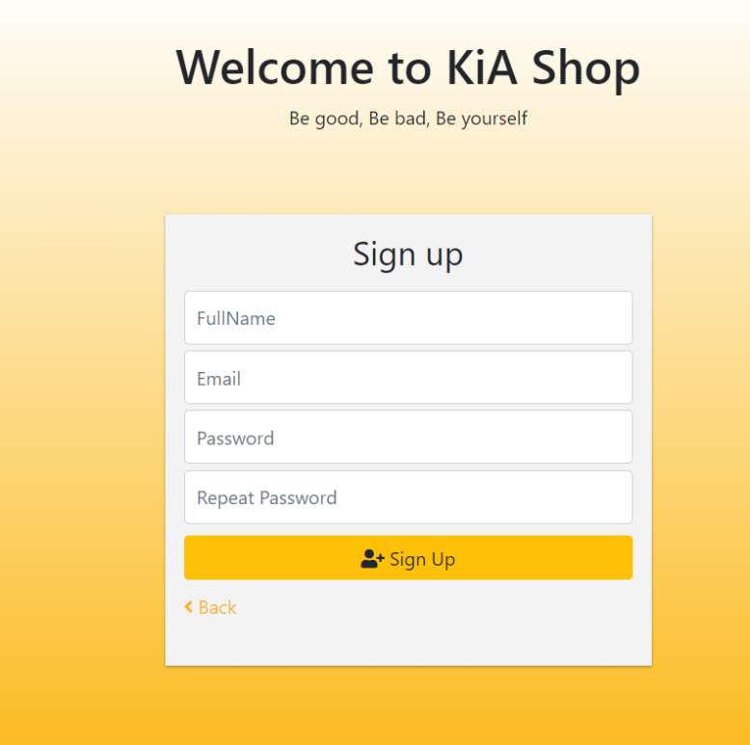

Figure 1.2 UI Sign Up

●Function details:

+This feature allows users to create an account on the website by providing their personal information such as name, email address, password. The registration process includes the following steps:

-The user navigates to the registration page.

-Users enter their full information into the text box.

-Users click on the "Register" button.

-The website displays a notification to the user indicating that their account has been successfully created.

- The system sends the pin code to the email that just registered

- website redirects to Pin code entry page

+ Acceptance criteria:

-The registration page can be accessed by clicking the "Register" link on the home page of the website.

-The website displays an error message if the provided user email is already in use.

-The website displays an error message if the user's password does not meet the minimum length or complexity requirements.

The website displays a message indicating that the account has been successfully created after the user clicks on the verification link.

- Enter the correct pin code sent to email

|  |  |  |
| --- | --- | --- |
| **Field Name** | **Field Type** | **Description** |
| Fullname* | Text Box | This is where the user enters fullname |
| Email* | Text Box | This is where the user enters their email |
| Password | Password Box | Enter the password you want |
| Repart Password | Password Box | Re-enter the password you just entered |
| Sign Up | Button | User clicks to create an account |

##### Database Access

|  |  |  |
| --- | --- | --- |
| **Table** | **CRUD** | **Description** |
| User | R | Verify email & Password information |

### **c. Forgot Password**

●Activation function: Click the forgotten password button on the login page.

●Function description: Customers want to change a new password if they forget the old password or want to change a new password

●Screen layout:

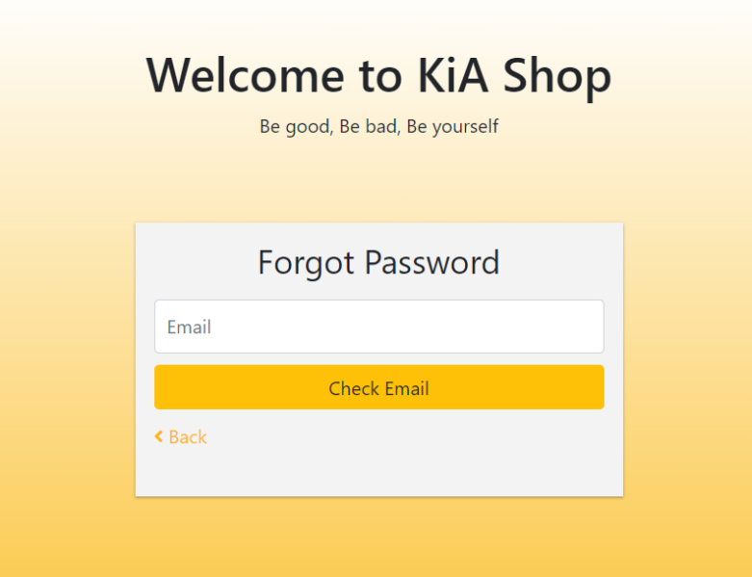

Figure 1.3 UI Forgot Password

●Function details:

+This feature allows users to re-enter a new password if they forget their account password or want to change another password The forgot password process includes the following steps:

-The user navigates to the Forgot password page.

-User enters registered email into the test box

-User clicks on the "Submit" button.

-The website checks if the email exists and goes to the password re-enter page, otherwise it reports an error

- The user re-enters the new password and confirms the password

- The system sends the pin code to the user's email

- website redirects to Pin code entry page

+ Acceptance criteria:

-Forgot password page will report an error if the user enters an email that does not exist

- The user enters a password that does not match the new password

- Enter the correct pin code sent to email

|  |  |  |
| --- | --- | --- |
| **Field Name** | **Field Type** | **Description** |
| Email* | Text Box | This is for user to input valid email address for logging in |
| Checkemail | Button | check email exists or not |

##### Database Access

|  |  |  |
| --- | --- | --- |
| **Table** | **CRUD** | **Description** |
| User | U | Verify Password information |

***SQL Commands:***

1/ Verify email information

select * from Accounts with email = ?

## 2. View Product Function

### 2.1 View Product feature

### **a. Sort Product**

●Activation function: Click on the “Price ” button on the home page to sort products by price, increasing or decreasing as desired

●Function description: The function helps customers sort shoe prices up or down to easily find suitable shoes for the available amount of money

●Screen layout:

|  |  |  |
| --- | --- | --- |
| **Field Name** | **Field Type** | **Description** |
| Price | Button | Users click to sort in increasing or decreasing order of price |

##### Database Access

|  |  |  |
| --- | --- | --- |
| **Table** | **CRUD** | **Description** |
| User,Guest | R | Sort products to see products that match customer requirements |

***SQL Commands:***

1/ Arrange products in ascending order

SELECT * FROM products ORDER BY price ASC;

2/Arrange products in descending order

SELECT * FROM products ORDER BY price DESC;

### **b. View Detail Product**

●Activation function: Click on the product name to see product details

●Function description: The function helps customers to see the detail of the product.

●Screen layout:

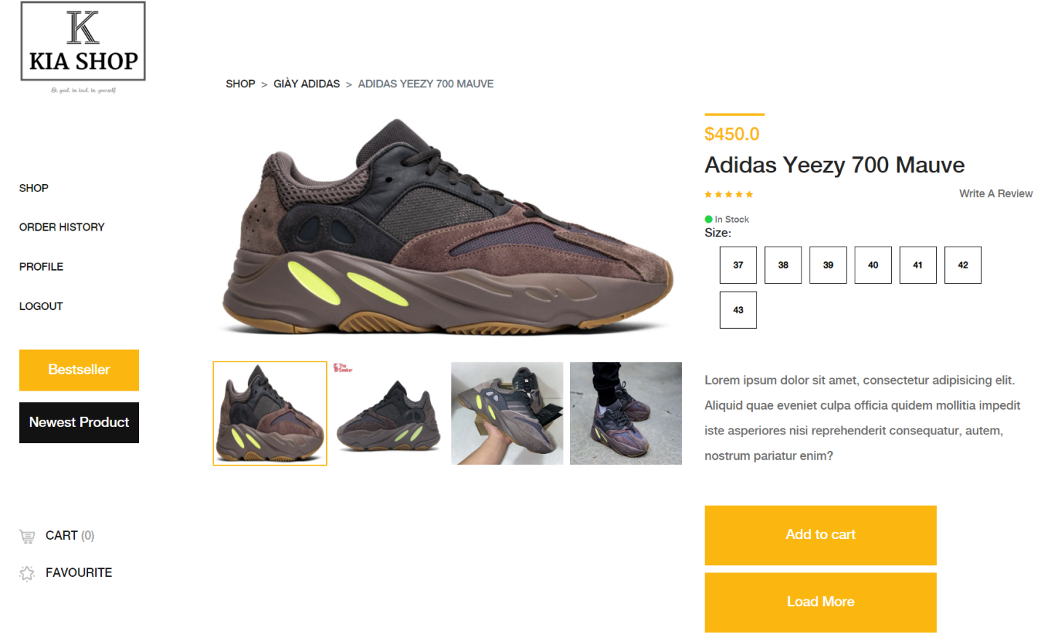

Figure 3.1 UI View Detail Product

|  |  |  |
| --- | --- | --- |
| **Field Name** | **Field Type** | **Description** |
| Add to Cart | Button | Users click to add the product to cart. |
| Bestseller | Button | Users click to see best-selling products |
| Newest Product | Button | Users click to see the latest products |
| Shop | Button | User clicks to return to the home page |
| Order History | Button | Users click to view purchase history |
| Profile | Button | User clicks to edit personal information |
| LogOut | Button | The user clicks to log out of the system |
| Cart | Button | User clicks to view shopping cart |

##### Database Access

|  |  |  |
| --- | --- | --- |
| **Table** | **CRUD** | **Description** |
| User,Guest | R | Read details of the product. |

***SQL Commands:***

SELECT * FROM products WHERE product_id = ?;

## 3. Manager Profile Function

### 3.1 Manager Profile feature

### **a. Update Account User**

●Activation function: Click on the Account button on the home page

●Function description:Function to help customers update their personal information

●Screen layout:

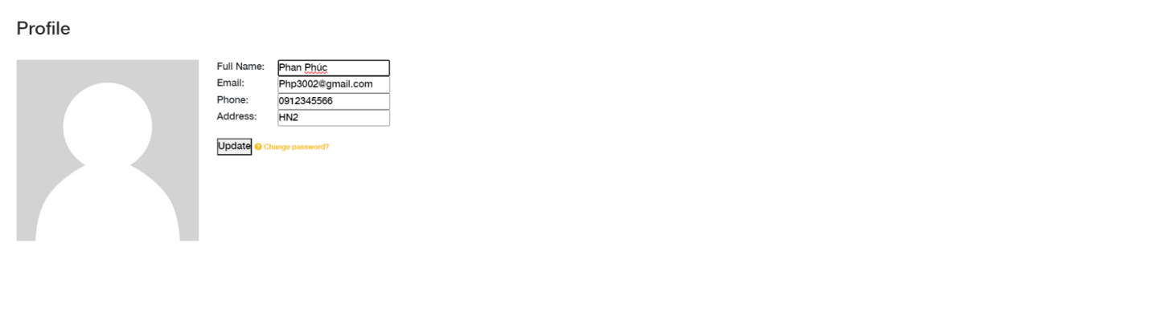

Figure 4.1 UI Update Profile

|  |  |  |
| --- | --- | --- |
| **Field Name** | **Field Type** | **Description** |
| Last name* | Text box | This is for users to input their last name. |
| First name* | Text box | This is for users to input their first name. |
| Address* | Text box | This is for users to input their address. |
| Phone | Text box | This is for users to input their phone number. |
| Mail | Text box | This is for user to input their mail address |
| Update information | Button | User clicks to update profile. |

##### 

##### Database Access

|  |  |  |
| --- | --- | --- |
| **Table** | **CRUD** | **Description** |
| User | U | Update information |

***SQL Commands:***

UPDATE users

SET first_name = ?, last_name = ?, email = ?

WHERE user_id = ?;

### **b. Change Password**

●Activation function: Click on the ‘change password’ button to change your password.

●Function description: The function helps customers to change their password.

●Screen layout:

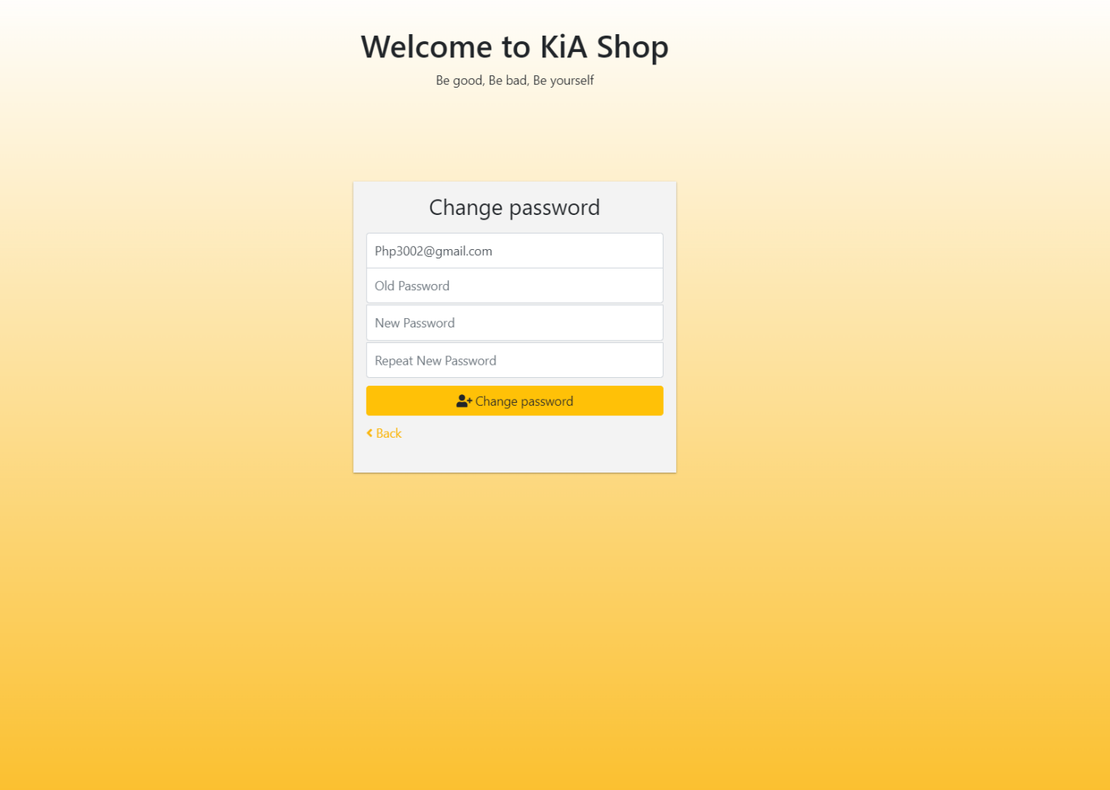

Figure 4.2 UI Change Password

|  |  |  |
| --- | --- | --- |
| **Field Name** | **Field Type** | **Description** |
| Email | Email box | User reviews registered email |
| New Password* | Password box | This is for user to input their new password |
| Confirm Password* | Password box | This is for user to confirm their new password |
| Change Password | Button | User clicks to successfully change the new password. |

##### Database Access

|  |  |  |
| --- | --- | --- |
| **Table** | **CRUD** | **Description** |
| User | U | Update new password |

***SQL Commands:***

UPDATE users

SET password = 'new_password'

WHERE user_id = 123;

## 4. Add Favorite Function

### 4.1 Add Favorite feature

### **a. Add Favorite Product**

●Activation function: Click on the ‘Heart’ button on the product.

●Function description:Function to help customers add products to their favorite product.

●Screen layout:

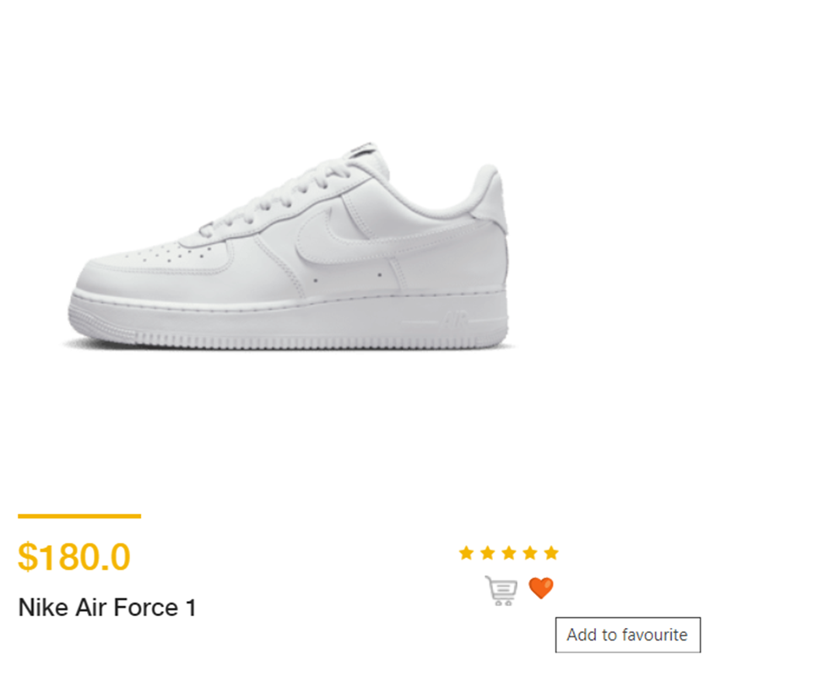

Figure 5.1 UI Add Favorite Product

|  |  |  |
| --- | --- | --- |
| **Field Name** | **Field Type** | **Description** |
| Add to favorite | Button | Users click to add the product to favorite. |

##### Database Access

|  |  |  |
| --- | --- | --- |
| **Table** | **CRUD** | **Description** |
| User | U | Add product to be the user's favorite. |

***SQL Commands:***

INSERT INTO favorite_products (user_id, product_id)

VALUES ('ID_user', 'ID_product');

## 5. View All Product Function

### 5.1 View All Product feature

### **a. *View All Products***

### 

●Activation function: Click on the icon below "VIEW ALL PRODUCTS" to view all products.

●Function description:Function used to view all products in the store.

●Screen layout:

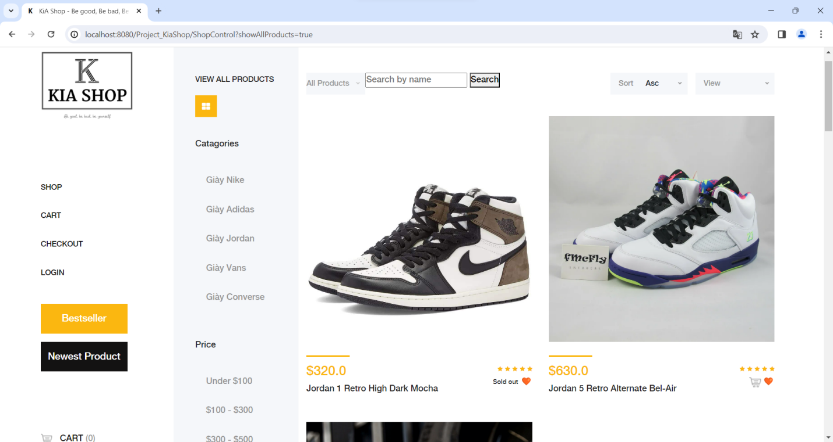

Figure 6.1 UI View All Product

|  |  |  |
| --- | --- | --- |
| **Field Name** | **Field Type** | **Description** |
| Search | Button | Users click to search for the desired product |
| Bestseller | Button | Users click to see best-selling products |
| Newest Product | Button | Users click to see the latest products |
| Shop | Button | User clicks to return to the home page |
| Order History | Button | Users click to view purchase history |
| Profile | Button | User clicks to edit personal information |
| Login | Button | The user clicks to login of the system |
| Cart | Button | User clicks to view shopping cart |
| Sort | Button | Users click to sort products as desired |
| Category | Button | Users click to see products with the same category |
| Price | Button | Users click to see products with the same price |

##### Database Access

***SQL Commands:***

select * from Product where isDeleted != 1

### **b. *View Product By Category***

●Activation function: Select by category to view the products of the category.

●Function description:View products in the selected category for selection.

●Screen layout:

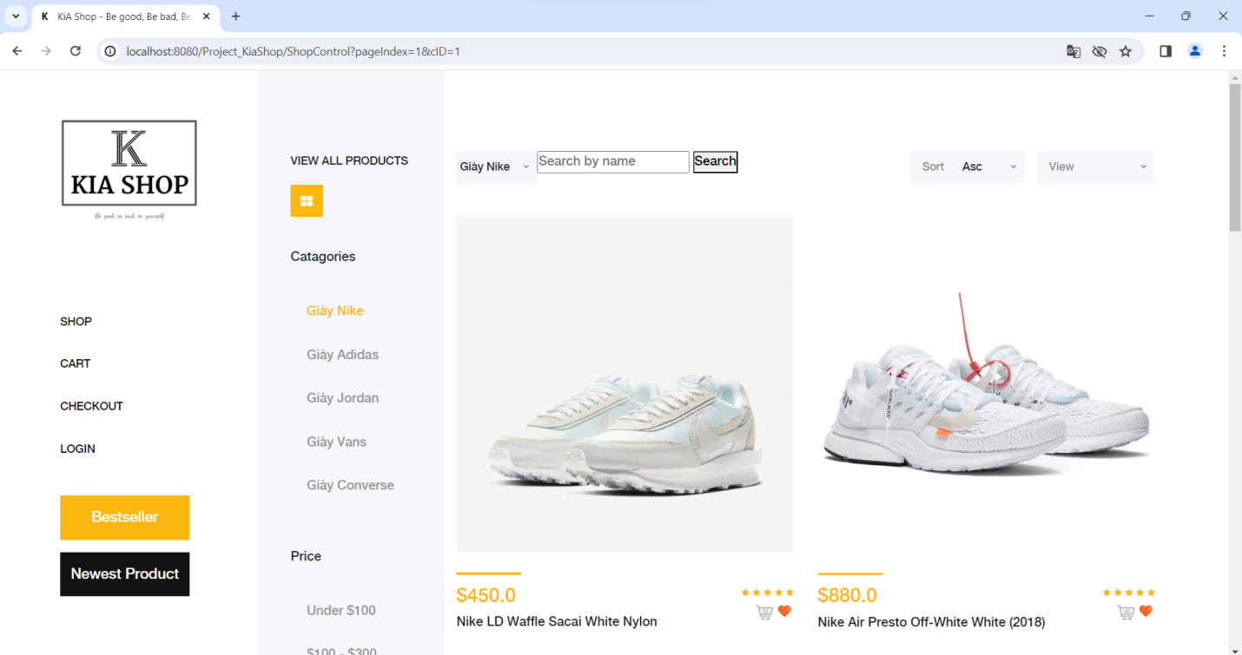

Figure 6.2 UI View Product By Category

|  |  |  |
| --- | --- | --- |
| **Field Name** | **Field Type** | **Description** |
| Search | Button | Users click to search for the desired product |
| Bestseller | Button | Users click to see best-selling products |
| Newest Product | Button | Users click to see the latest products |
| Shop | Button | User clicks to return to the home page |
| Order History | Button | Users click to view purchase history |
| Profile | Button | User clicks to edit personal information |
| Login | Button | The user clicks to login of the system |
| Cart | Button | User clicks to view shopping cart |
| Sort | Button | Users click to sort products as desired |
| Category | Button | Users click to see products with the same category |
| Price | Button | Users click to see products with the same price |

##### Database Access

***SQL Commands:***

select * from Category

select * from Product where cID = ? and isDeleted != 1

### **c. *Search Product By Name***

●Activation function: Select by category to view the products of the category.

●Function description: Enter the keyword you want to search for in the search box and press the "Search" button or the enter key on the keyboard to search for the product.

●Screen layout:

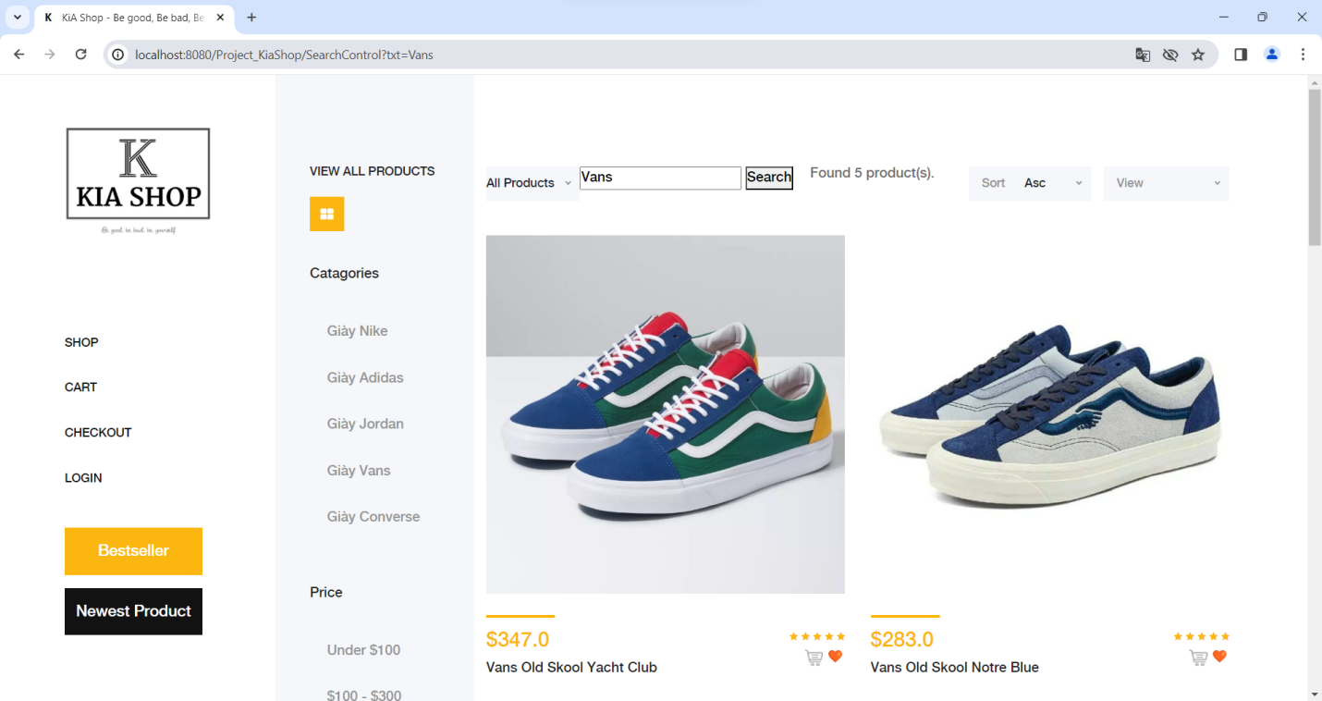

Figure 6.3 UI Search Product by Name

|  |  |  |
| --- | --- | --- |
| **Field Name** | **Field Type** | **Description** |
| Search | Button | Users click to search for the desired product |
| Bestseller | Button | Users click to see best-selling products |
| Newest Product | Button | Users click to see the latest products |
| Shop | Button | User clicks to return to the home page |
| Order History | Button | Users click to view purchase history |
| Profile | Button | User clicks to edit personal information |
| Login | Button | The user clicks to login of the system |
| Cart | Button | User clicks to view shopping cart |
| Sort | Button | Users click to sort products as desired |
| Category | Button | Users click to see products with the same category |
| Price | Button | Users click to see products with the same price |

##### Database Access

***SQL Commands:***

SELECT * FROM Product WHERE isDeleted != 1

select * from Product where pName like ?

## 6. Manager Customer Function

### 6.1 Manager Customer feature

### **a. *Management customer***

●Activation function: Login with Admin account and select customer management to enter the customer management page.

●Function description: Enter the keyword you want to search for in the search box and press the "Search" button or the enter key on the keyboard to search for the product.

●Screen layout:

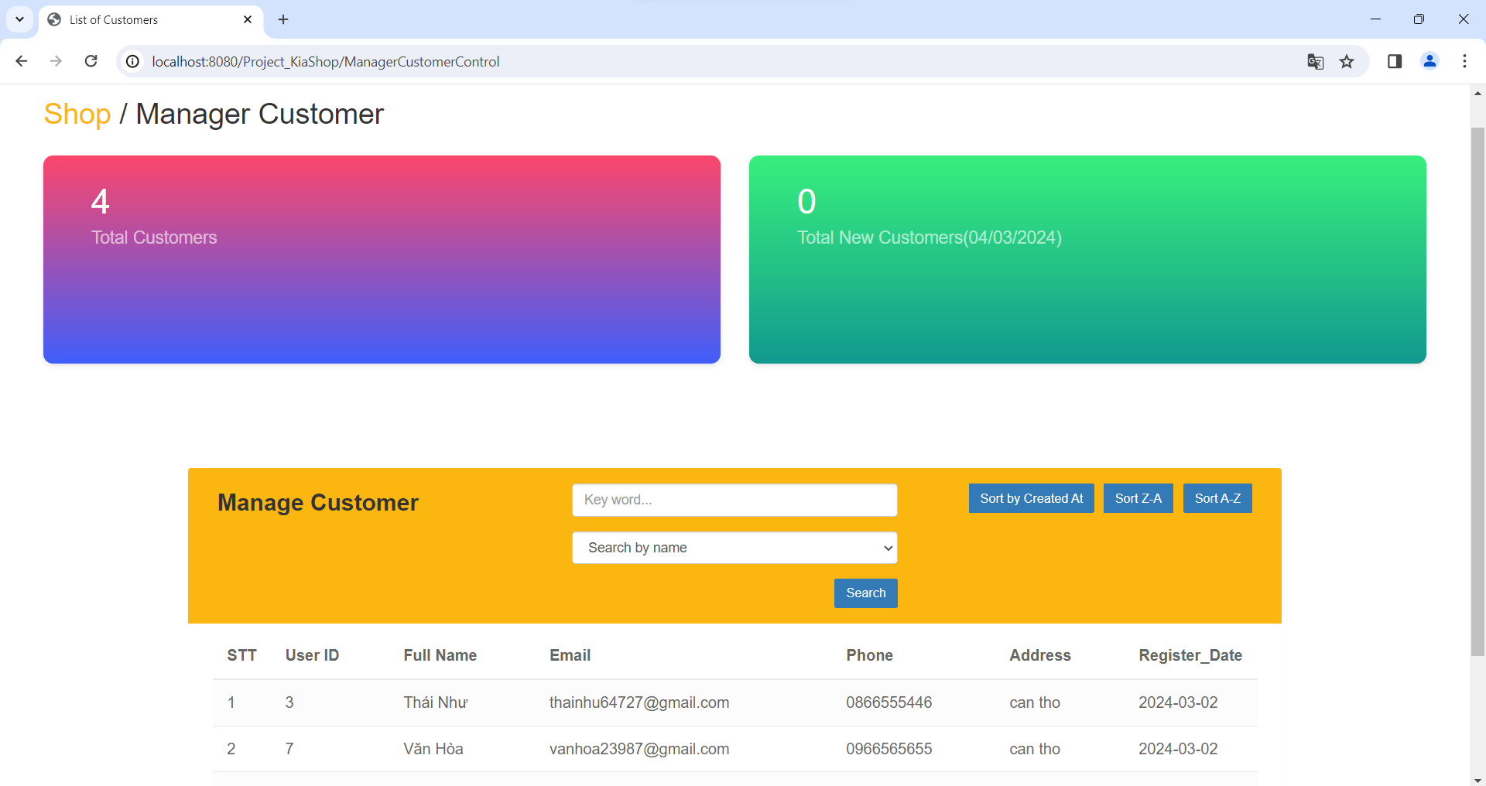

Figure 7.1 UI Manager Customer

|  |  |  |
| --- | --- | --- |
| **Field Name** | **Field Type** | **Description** |
| Sort By Created At | Button | Admin view latest customers |
| Sort Z-A | Button | Admin views customers alphabetically from Z-A |
| Sort Z-A | Button | Admin views customers alphabetically from A-Z |
| Search | Button | Admin click to search for customers by name |

##### Database Access

|  |  |  |
| --- | --- | --- |
| **Table** | **CRUD** | **Description** |
| Admin | CR | View all information customer |

***SQL Commands:***

SELECT * FROM Account where role = 0

### **b. *Search customer by name***

●Activation function: sort customers by name

●Function description: enter the name admin want and press search

●Screen layout:

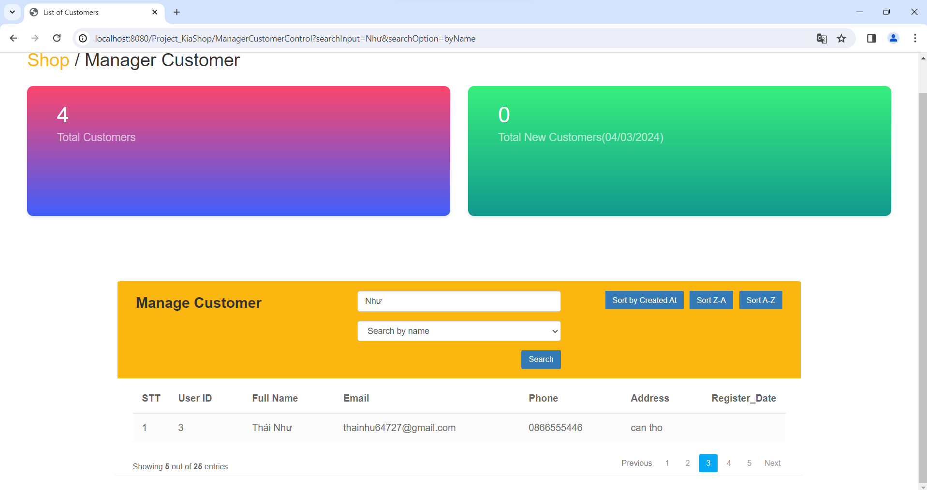

Figure 7.2 UI Search Customer By Name

|  |  |  |
| --- | --- | --- |
| **Field Name** | **Field Type** | **Description** |
| Sort By Created At | Button | Admin view latest customers |
| Sort Z-A | Button | Admin views customers alphabetically from Z-A |
| Sort Z-A | Button | Admin views customers alphabetically from A-Z |
| Search | Button | Admin click to search for customers by name |

##### Database Access

|  |  |  |
| --- | --- | --- |
| **Table** | **CRUD** | **Description** |
| Admin | CR | View all information customer by name |

***SQL Commands:***

SELECT * FROM Account WHERE LOWER(fullname) LIKE LOWER(?) AND role = 0

### **c. *Search customer by phone number***

●Activation function: sort customers by phone number

●Function description: enter the phone number admin want and press search

●Screen layout:

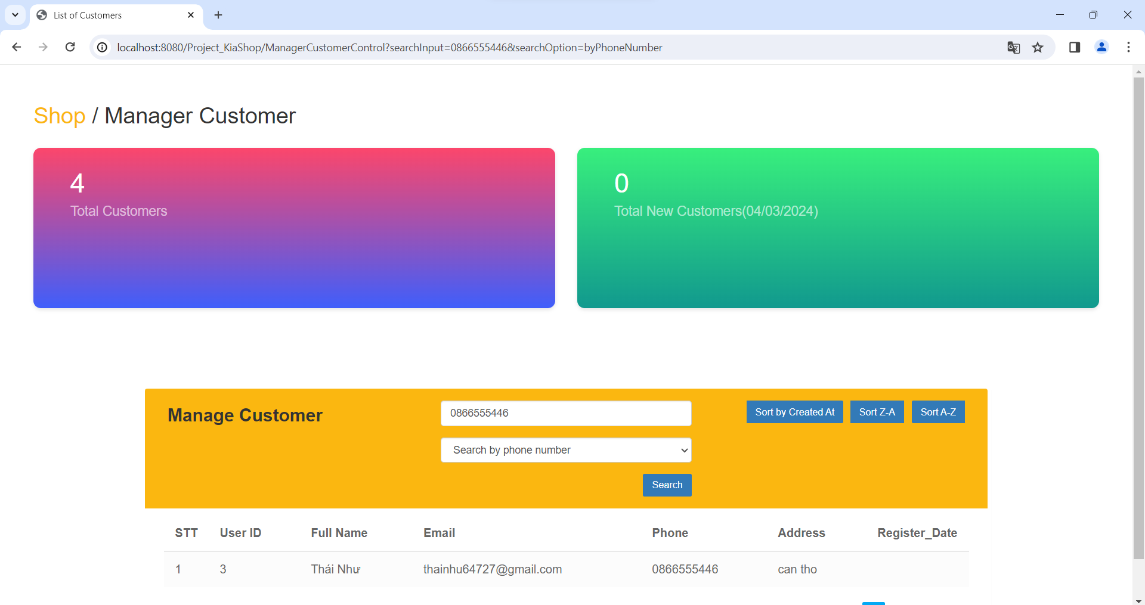

Figure 7.3 UI Search Customer By Phone

|  |  |  |
| --- | --- | --- |
| **Field Name** | **Field Type** | **Description** |
| Sort By Created At | Button | Admin view latest customers |
| Sort Z-A | Button | Admin views customers alphabetically from Z-A |
| Sort Z-A | Button | Admin views customers alphabetically from A-Z |
| Search | Button | Admin click to search for customers by name |

##### Database Access

|  |  |  |
| --- | --- | --- |
| **Table** | **CRUD** | **Description** |
| Admin | CR | View all information customer by number phone |

***SQL Commands:***

SELECT * FROM Account WHERE phone LIKE ? and role = 0

### **d. *Sort customer***

●Activation function: sort customers in order from A-Z or vice versa

●Function description: click the sort button you want

●Screen layout:

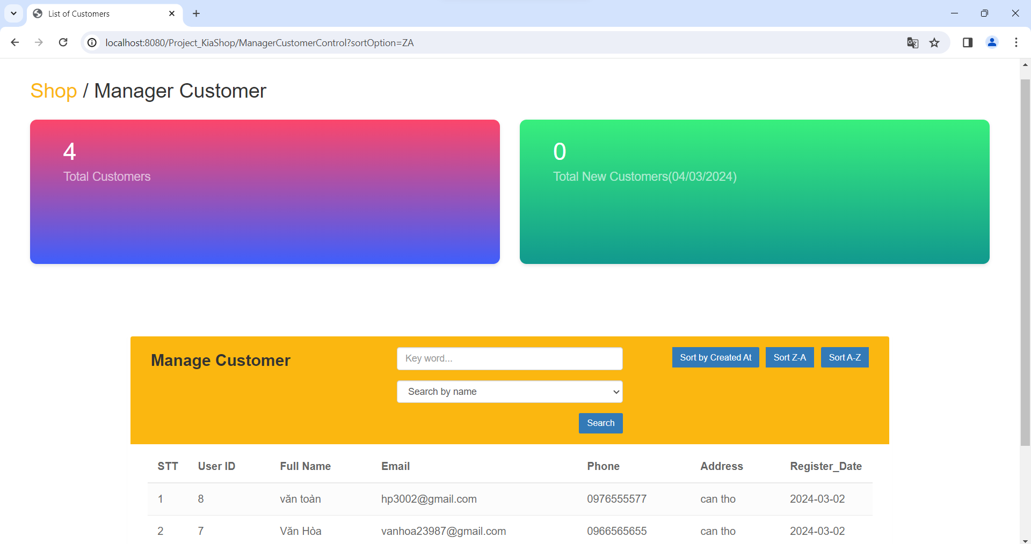

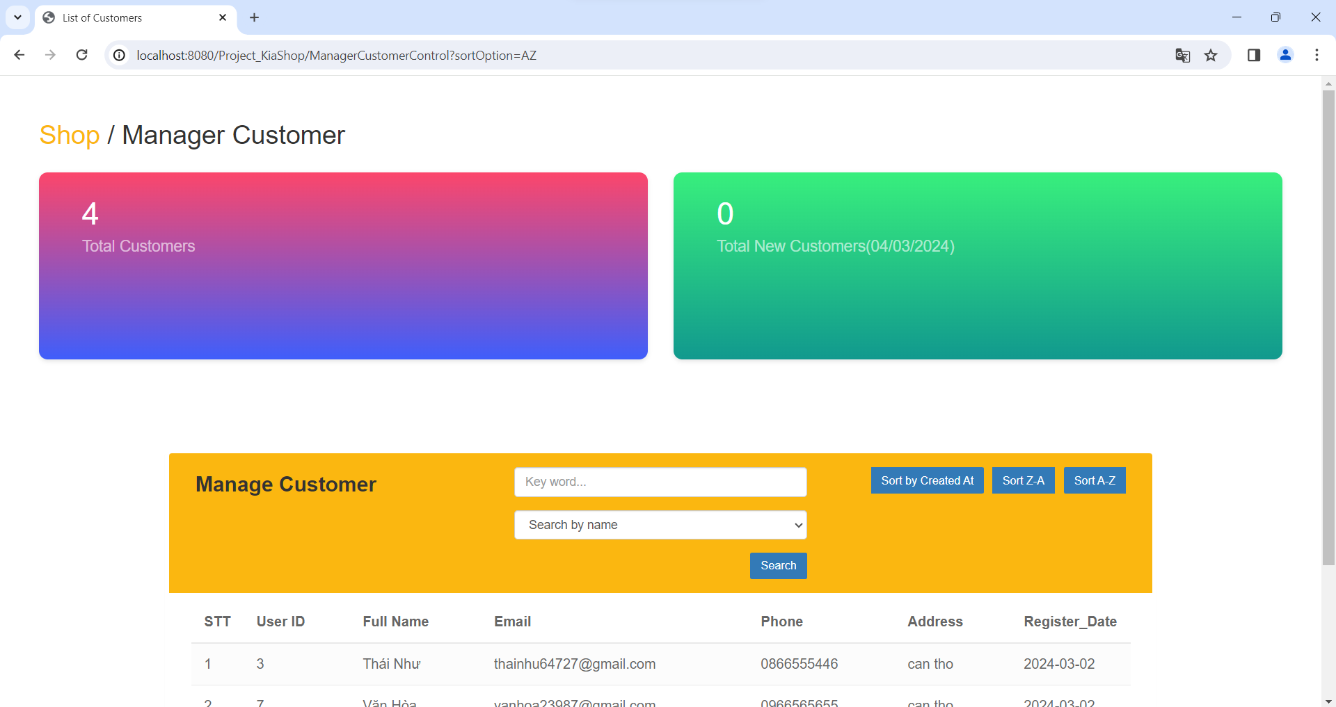

Figure 7.4 UI Sort Customer A-Z or Z-A

|  |  |  |
| --- | --- | --- |
| **Field Name** | **Field Type** | **Description** |
| Sort By Created At | Button | Admin view latest customers |
| Sort Z-A | Button | Admin views customers alphabetically from Z-A |
| Sort Z-A | Button | Admin views customers alphabetically from A-Z |
| Search | Button | Admin click to search for customers by name |

##### Database Access

|  |  |  |
| --- | --- | --- |
| **Table** | **CRUD** | **Description** |
| Admin | CR | View all information customer |

***SQL Commands:***

select * from Product where isDeleted != 1

## 7. Manager Product Function

## 7.1 Manager Product feature

### **a. *Management products***

●Activation function: view product information total product amount

●Function description: the system displays all product information

●Screen layout:

### 

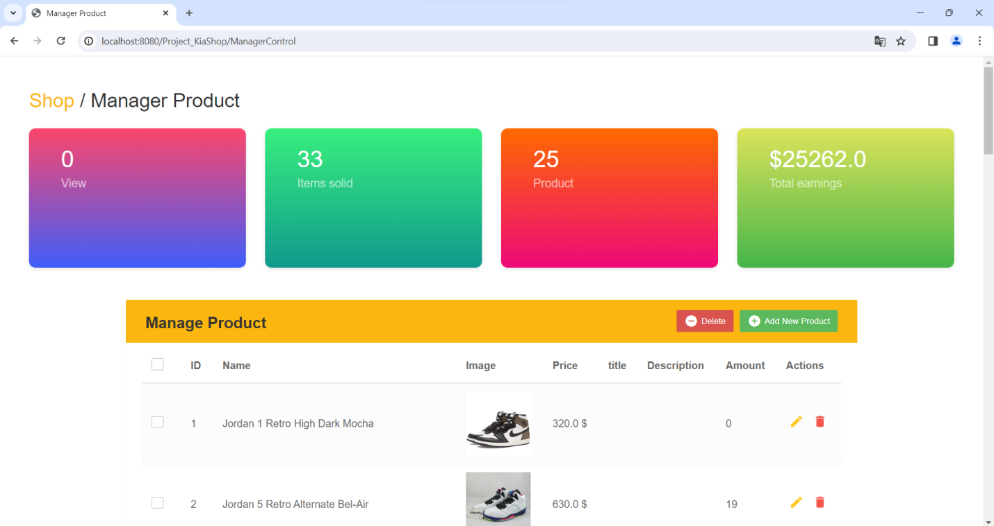

Figure 8.1 UI Manager Product

|  |  |  |
| --- | --- | --- |
| **Field Name** | **Field Type** | **Description** |
| Manager product | Button | Admin clicks on the manager product button to view all the product |
| Delete | Button | Admin removes product from website |
| Add new Product | Button | Admin adds products to the website |
| Update Product | Button | Admin edits product information |

##### Database Access

|  |  |  |
| --- | --- | --- |
| **Table** | **CRUD** | **Description** |
| Admin | CR | View all information product |

***SQL Commands:***

select * from Product where isDeleted != 1

### **b. *Add new product***

●Activation function: select the add button to add the product to the website

●Function description: enter new product information to add to the website

●Screen layout:

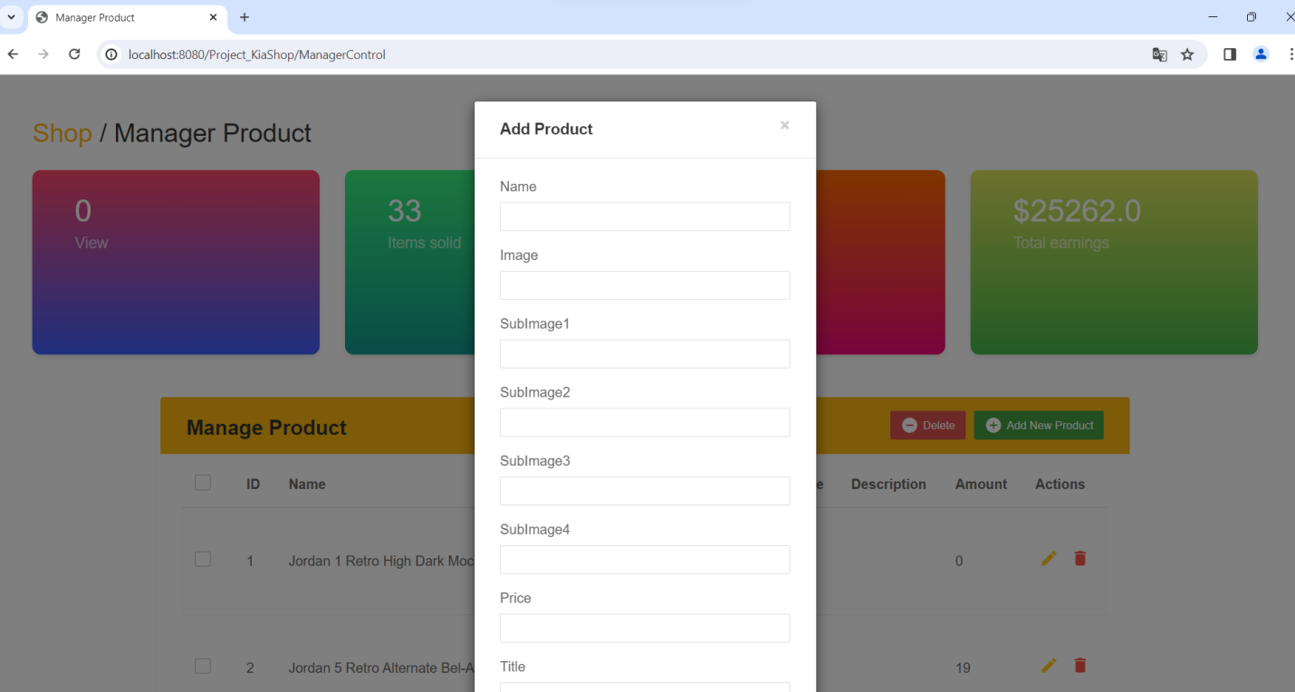

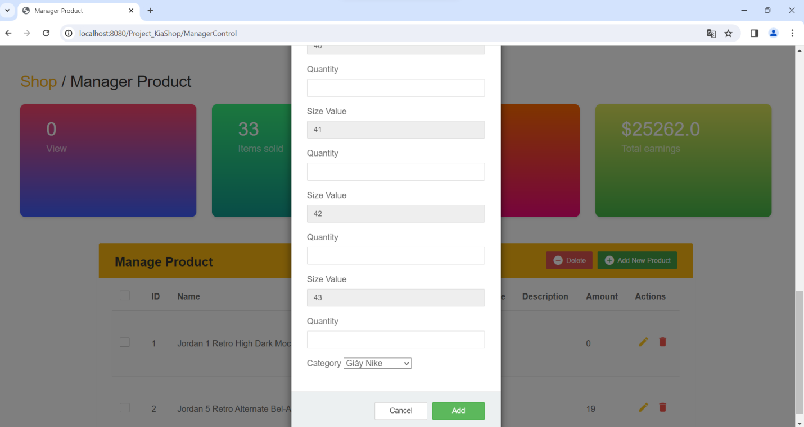

Figure 8.2 UI Add New Product

|  |  |  |
| --- | --- | --- |
| **Field Name** | **Field Type** | **Description** |
| Manager product | Button | Admin clicks on the manager product button to view all the product |
| Delete | Button | Admin removes product from website |
| Add new Product | Button | Admin adds products to the website |
| Update Product | Button | Admin edits product information |

##### Database Access

|  |  |  |
| --- | --- | --- |
| **Table** | **CRUD** | **Description** |
| Admin | CR | Add new information product |

***SQL Commands:***

INSERT into Product (pName, [image], price, title, [description], cID, pAmount, isDeleted) VALUES (?, ?, ?, ?, ?, ?, ?, 0)"

### **c. *Delete product***

●Activation function: select the delete button to delete the product from the website

●Function description: click the delete button to delete the product

●Screen layout:

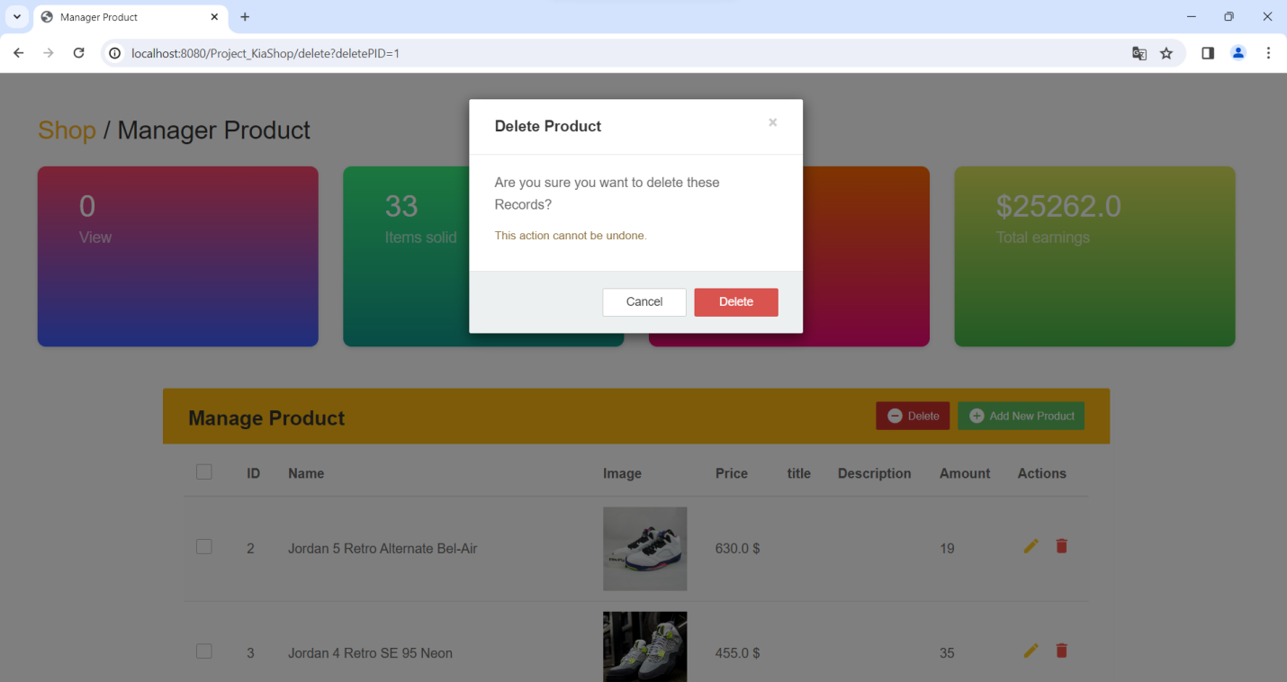

Figure 8.3 UI Delete Product

|  |  |  |
| --- | --- | --- |
| **Field Name** | **Field Type** | **Description** |
| Manager product | Button | Admin clicks on the manager product button to view all the product |
| Delete | Button | Admin removes product from website |
| Add new Product | Button | Admin adds products to the website |
| Update Product | Button | Admin edits product information |

##### Database Access

|  |  |  |
| --- | --- | --- |
| **Table** | **CRUD** | **Description** |
| Admin | D | Delete information product |

***SQL Commands:***

Update Product set isDeleted = 1 WHERE pID = ?

### **d. *Update product***

●Activation function: select update button to update product information

●Function description: enter the information you want to modify then click the save button to update

●Screen layout:

# 

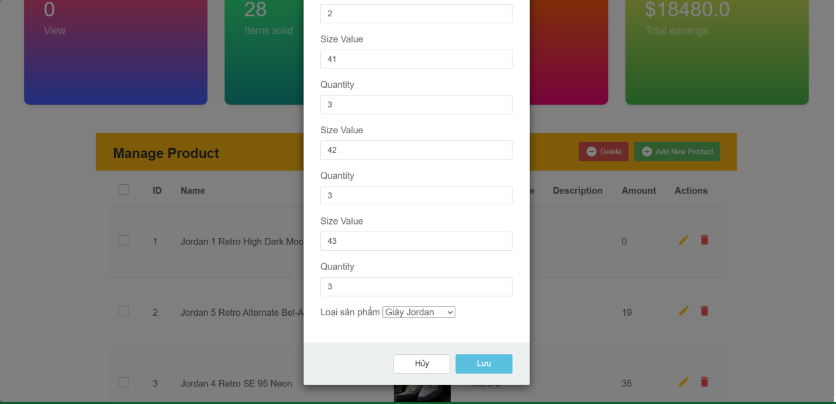

Figure 8.4 UI Update Product

|  |  |  |
| --- | --- | --- |
| **Field Name** | **Field Type** | **Description** |
| Manager product | Button | Admin clicks on the manager product button to view all the product |
| Delete | Button | Admin removes product from website |
| Add new Product | Button | Admin adds products to the website |
| Update Product | Button | Admin edits product information |

##### Database Access

|  |  |  |
| --- | --- | --- |
| **Table** | **CRUD** | **Description** |
| Admin | U | Update information product |

***SQL Commands:***

UPDATE Product set pName = ?, image = ?, price = ?, title = ?, description = ?, cID = ?, pAmount = ? where pID = ?

## 8. Manager Order Function

### 8.1 Manager Order feature

### **a. Manager Order**

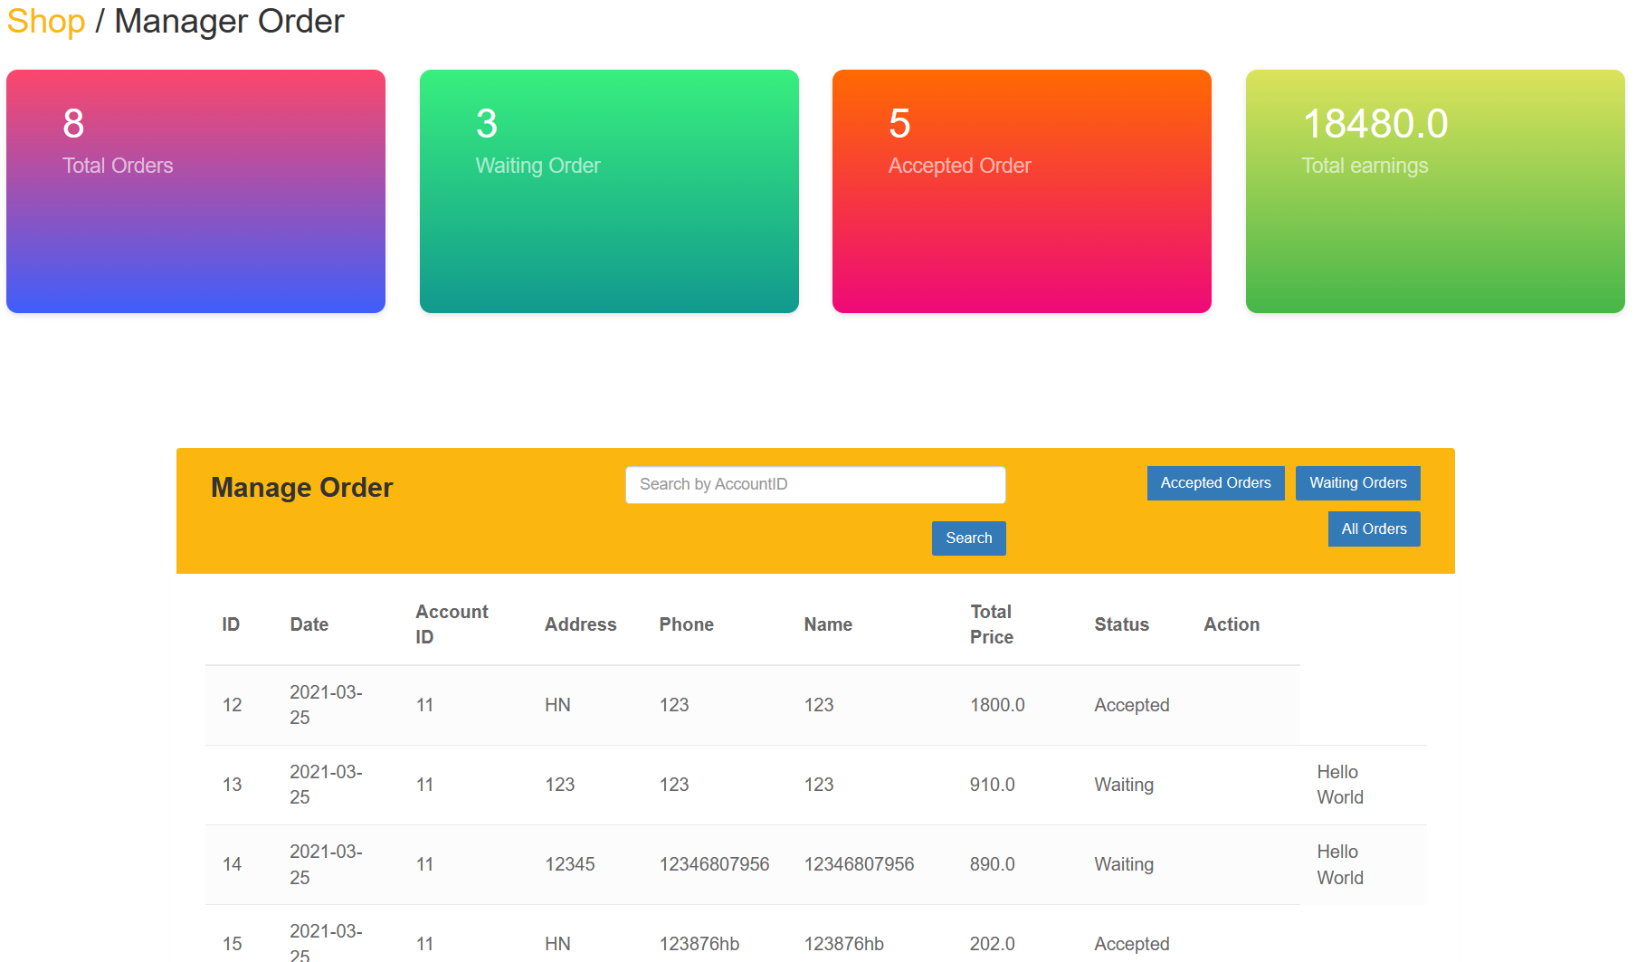

Figure 9.1 UI Manager Order

|  |  |  |
| --- | --- | --- |
| **Field Name** | **Field Type** | **Description** |
| Manager order | Button | Admin clicks on the manager product button to view all the product |
| Accepted Order | Button | Admin views all Accepted orders |
| Waiting Order | Button | Admin views all Waiting orders |
| All Orders | Button | Admin view all orders |
| Search | Button | Admin click to search orders by customer ID |

##### Database Access

|  |  |  |
| --- | --- | --- |
| **Table** | **CRUD** | **Description** |
| Admin | U | Update information product |

***SQL Commands:***

UPDATE Product set pName = ?, image = ?, price = ?, title = ?, description = ?, cID = ?, pAmount = ? where pID = ?

### **b. Sort Accept Order List**

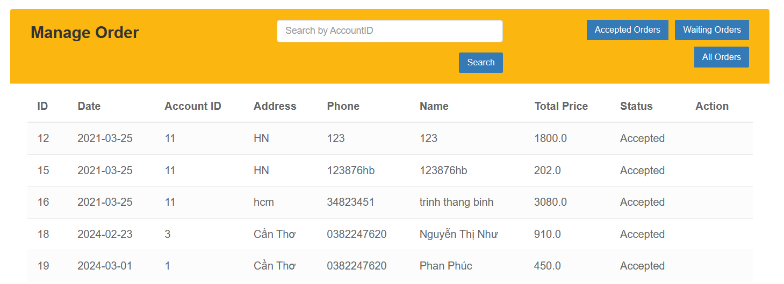

Figure 9.2 UI Accept Order List

|  |  |  |
| --- | --- | --- |
| **Field Name** | **Field Type** | **Description** |
| Manager order | Button | Admin clicks on the manager product button to view all the product |
| Accepted Order | Button | Admin views all Accepted orders |
| Waiting Order | Button | Admin views all Waiting orders |
| All Orders | Button | Admin view all orders |
| Search | Button | Admin click to search orders by customer ID |

##### Database Access

|  |  |  |
| --- | --- | --- |
| **Table** | **CRUD** | **Description** |
| Admin | U | Update information product |

***SQL Commands:***

select * from [Project_KiAShop5].[dbo].[Order] where status =’Accepted’

### **c. Sort Waiting Order List**

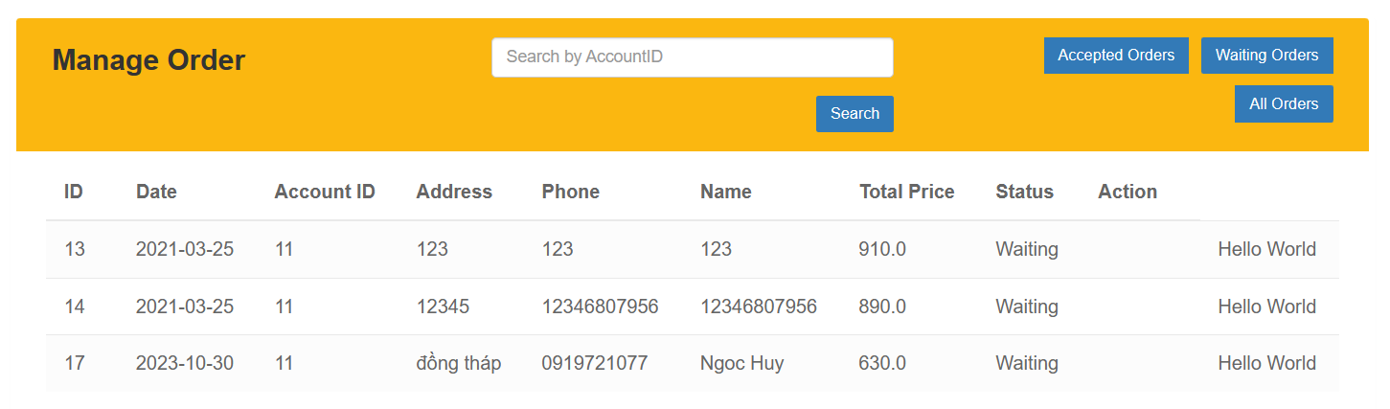

Figure 9.3 UI Waiting Order List

|  |  |  |
| --- | --- | --- |
| **Field Name** | **Field Type** | **Description** |
| Manager order | Button | Admin clicks on the manager product button to view all the product |
| Accepted Order | Button | Admin views all Accepted orders |
| Waiting Order | Button | Admin views all Waiting orders |
| All Orders | Button | Admin view all orders |
| Search | Button | Admin click to search orders by customer ID |

##### Database Access

|  |  |  |
| --- | --- | --- |
| **Table** | **CRUD** | **Description** |
| Admin | U | View information Order |

***SQL Commands:***

select * from [Project_KiAShop5].[dbo].[Order] where status =’Waiting’

# IV. Appendix

## 1. Assumptions & Dependencies

AS-1: Browser Compatible

It is assumed that the online shoe store will be compatible with popular web browsers (e.g. Chrome, Firefox, Safari). The project depends on users being able to access and use the website smoothly across different browsers without significant functional differences.

AS-2: Product Information Availability

The success of an online shoe store depends on accurate and up-to-date product information. It is assumed that product details, including images, descriptions and prices, will be available and maintained on a regular basis by system administrators.

AS-3: Secure Transaction

The assumption is that an online shoe store will provide a secure environment for transactions. Users should feel confident that their payment information is handled securely. Project success depends on implementing and maintaining strong security measures.

DE-1: Inventory Management System

Project success depends on integration with an effective inventory management system. This includes real-time tracking of inventory levels, automatic updates on product availability, and synchronization with the online store to prevent overselling.

## 2. Limitations & Exclusions

HL-1: Online product testing

The project does not include a feature for online testing, where users can try on shoes online before purchasing.

HL-2: Product rating and review system

The project does not include features for user reviews and ratings of products.

## 3. Business Rules

|  |  |  |
| --- | --- | --- |
| ID | Category | Rule Definition |
| FR1 | Password Encoding | User’s password must be encoded with MD5 hashing |
| FR2 | Account creation failed | Users cannot create an account if they make the following errors  · email matches the registered email  . invalid phone number  . Password is not of sufficient length |
| FR2 | Invalid Logging In | User can’t be authenticated to login the system if below cases  · His/her logging-in details are incorrect  · His/her account has not been verified  · His/her account has been locked or blocked |
| FR3 | Account Locking | If user inputs wrong logging-in details 6 times continuously, his/her account would be locked in 30 minutes |
| FR3 | Username and email addresses | Usernames and email addresses must be unique within the system. |
| FR1 | Comment Product | Comments product must comply with community standards and must not have negative connotations |
| FR1 | Reply Comment | Reply comments must comply with community standards and must not have negative connotations |
| FR1 | Show Comment | Display comments must comply with community standards and must not be negative  Hide negative comments |